Resources

Library Services
Library Services provides you with the books, journals and other online resources that you need to succeed on your course.

Dudley College Library
The Dudley College main library is situated at the Broadway campus. Use your Dudley College student cards to borrow books from here. Most of the necessary materials for your course are accessible online through the University of Worcester library pages.

Term time opening hours:
Monday: 8.15am - 5pm
Tuesday-Thursday: 8.15am -7pm
Friday: 8.15am-4.30pm

Online resources and recommended reading
Start your reading by looking at the resource list in each of your Blackboard modules. These contain key readings recommended by your course team. You’ll find lots of ebooks and online journal articles from the University of Worcester- click the View Online links.

Library Search gives you access to books and articles beyond your resource list.

Focus your search to online articles or ebooks using the tabs:
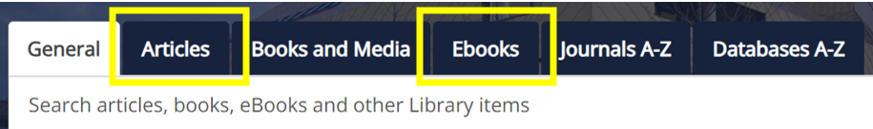

Library Services subject guides are the place to look for specialist resources including recommended research databases.

If you need a journal article or book chapter that is not part of our subscriptions we may be able to supply it via our inter-library request service. If you need the occasional book that is not available online but is available in print via Library Services, we can arrange for the book to be posted to you. You will need to pay to post it back to us on time. Be aware that postal loans take time to arrange.

You can listen to our ebooks if you prefer. If you struggle to read print comfortably due to dyslexia, autism, ADHD, a visual impairment or physical disability then Bookshare is for you.

Referencing in your academic work
Referencing is an important part of your academic writing. It enables you to show what you have been reading, and how it has influenced your thinking and reasoning. For your assignments, use Harvard Cite Them Right 12th edition. The Library Services referencing webpage provides links to the referencing guides you need, as well as links to guidance on academic integrity and the University assessment policy. Our Academic Liaison Librarians can help with guidance on referencing, reference management tools and reference generators at any point in your course.

Guidance and advice
Our Academic Liaison Librarians will teach skills throughout your course which will enable you to find, organise, evaluate, and reference information effectively.

Quick queries
Got a quick query about finding or using sources, or about referencing?
- Search our Frequently Asked Questions
- Email the Ask a Librarian team: askalibrarian@worc.ac.uk
- Live chat with a librarian, 12-5pm Monday to Friday and 12-2pm on Saturdays during term time.

For more in-depth guidance:
- Book a place on one of our online workshops. These online, interactive webinars cover a range of topics including searching for sources, referencing sources, using University of Worcester ebooks, support for systematic reviews and much more.
- Book an online appointment with your academic liaison librarian.

Library Services videos, screencasts, and social media:
Follow us on Instagram, TikTok and YouTube. Search @UWLibraryServices

The Hive
If you are visiting Worcester, we would love to see you in The Hive. The Hive is Worcester’s joint University and public library. If you wish to borrow books, your University of Worcester student ID is your library card. Show your University of Worcester ID Card for a 10% discount in The Hive café. Before you visit you might like to look at:

- Opening hours and parking information
- Sensory guide to The Hive

Using other university libraries
Apply via SCONUL Access if you would like to use study spaces, books or journals at other university libraries. The website tells you which libraries participate.

