Resources

Library Services
Library Services provides you with the books, journals and other online resources that you need to succeed on your course.

Online resources and recommended reading
Start your reading by looking at the resource list in each of your Blackboard modules. These contain key readings recommended by your course team. You’ll find lots of ebooks and online journal articles from the University of Worcester- click the View Online links.

Library Search gives you access to books and articles beyond your resource list.

Focus your search to online articles or ebooks using the tabs:
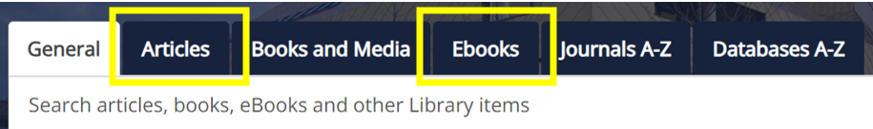

Library Services subject guides are the place to look for specialist resources including recommended research databases.

If you need a journal article or book chapter that is not part of our subscriptions we may be able to supply it via our inter-library request service.

There are tools available if you prefer to listen to ebooks.

Referencing in your academic work
Referencing is an important part of your academic writing. It enables you to show what you have been reading, and how it has influenced your thinking and reasoning. For your assignments, use Harvard Cite Them Right 12th edition. The Library Services referencing webpage provides links to the referencing guides you need, as well as links to guidance on academic integrity and the University assessment policy. If you are permitted to use artificial intelligence in preparing for your assessments you will need to know how to acknowledge it. Our Academic Liaison Librarians can help with guidance on referencing, reference management tools and reference generators at any point in your course.

Guidance and advice
Our Academic Liaison Librarians will teach skills throughout your course which will enable you to find, organise, evaluate and reference information effectively.

Quick queries
Got a quick query about finding or using sources, or about referencing?
- Search our Frequently Asked Questions
- Email the Ask a Librarian team: askalibrarian@worc.ac.uk
- Live chat with a librarian, 12-5pm Monday to Friday and 12-2pm on Saturdays during term time.

For more in-depth guidance:
- Book a place on one of our online workshops covering a range of topics including searching for sources, referencing sources, using University of Worcester ebooks, support for systematic reviews and much more.
- Book an online appointment with your academic liaison librarian. Let us know if none of the advertised times work for you.

Library Services videos, screencasts, and social media:
Follow us on Instagram, TikTok and YouTube. Search @UWLibraryServices

