Note:

Brief description of the activity being assessed

Title of Assessment: |  | People involved in making this assessment: | Any other team members involved?
Risk Assessment Reference & Version |  | Date of Assessment:
Risk Assessor (Name & Position) |  | Date of Review | Note Annually or If changes are needed due to a change in the business operations
Approved by (head of school / department):  Date: |  | Process of communicating to relevant persons  FOR EXAMPLE –  Information will be shared in the Team Meeting, team discussions / Email communication etc…
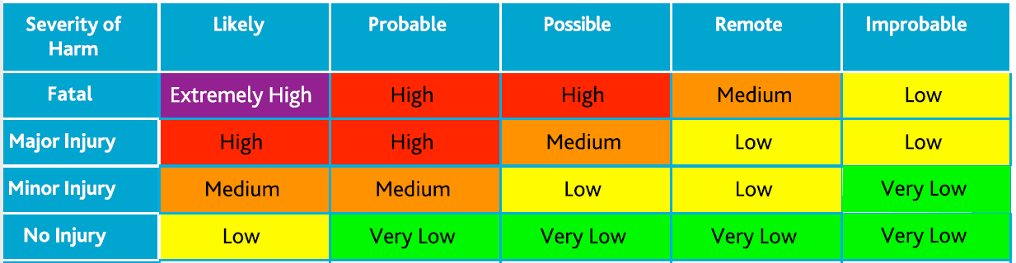
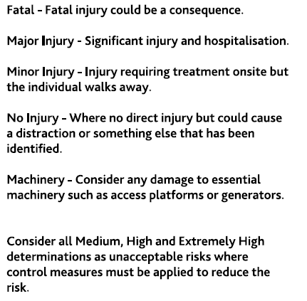

Hazards  (A hazard is something that can cause harm, e.g. electricity, chemicals, working up a ladder, noise, car, DSE, | People at Risk  (Students, Staff, Visitors, Contractors, Other) | What harm might occur,  (Slips Trips, Falls, Breaks, Sprains etc…) | Control Measures already in place  (Control measures include actions that can be taken to reduce the potential of exposure to the hazard). | Evaluate the Risk  (Having identified the hazards and controls, decide how likely it is that harm will occur), | Additional Control Measures  (Only necessary when additional controls are required.  These controls form part of the standard control measures when implemented.) | Revaluate the risk  By adding the additional controls, has the rating changed?

Action Ref | Action required | Who is responsible? | By when? | Date completed / Comments
1

