Display Screen Equipment (DSE) Work Station Assessment

Name:
Department:
Staff Number:
Telephone Number:
Email Address:
Campus/Building/Room Number:
Name of Line Manager:
Type of DSE:
Desktop computer
Laptop and Docking station
Laptop
iPad/Samsung tablet

Risk factors | Yes | No | Things to consider | Comments | Action required
- Display screen
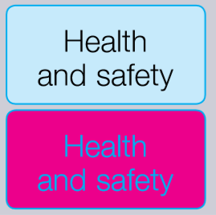  Are characters clear and readable? |  |  | Make sure that the screen is clean and that cleaning materials are available. Check that text and background colours work well together.
Is the text a comfortable size to read? |  |  | Software settings may need adjusting to change text size.
Is the image stable, i.e. free of flicker? |  |  | Try using different screen colours to reduce flicker, e.g. darker background and lighter text. If the problem persists, have the set up checked by IT.
Is the screen size suitable for the intended use? |  |  | For example, intensive graphic work or work requiring fine attention to small details may require large display screens.
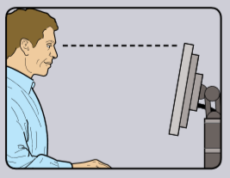  Does the screen swivel and tilt? |  |  | Separate adjustment controls are not essential provided the user can read the screen easily at all times.
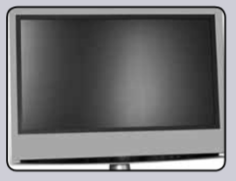  Is the screen free from glare and reflections? |  |  | You might need to move the screen or desk and/or shield the screen from the source of reflections. Screens that use dark characters on a light background are less prone to glare and reflections.
Are blinds provided and in an adequate condition/position? |  |  | Check that blinds work, if these measures do not work consider anti-glare frosting/filters. Blinds with vertical slats can be more suitable than horizontal ones.
- Keyboard
Is the keyboard separate from the screen?
Does the keyboard tilt? |  |  | Keyboard does not have to be tilted if not comfortable.
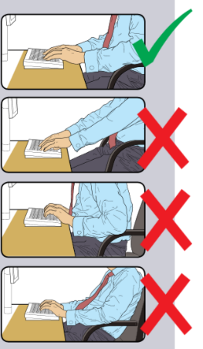  Do you have a comfortable typing position? |  |  | Try pushing the display screen further back to create more room for the keyboard, hands and wrists. Some keyboard users may find a wrist-rest useful.
Are the characters on the keys easily readable? |  |  | Keyboards should be kept clean, if the characters are not readable then the keyboard needs to be replaced. Use a keyboard with a matt finish to reduce glare and/or reflection.
- Mouse/Trackball
Is the device suitable for the task it is being used for? |  |  | The mouse/trackball are general purpose devices suitable for many tasks and available in a variety of shapes and sizes. If the user is having problems, try a different device.
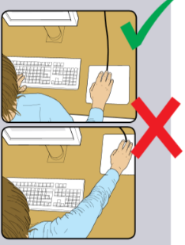  Is the device positioned close to you? |  |  | Most devices are best placed as close as possible, e.g. right beside the keyboard. The arm should not be overreaching, it should be relaxed and the hand should not be left on the device when it is not being used.
Is there support for your wrist and forearm? |  |  | The user should be able to find a comfortable working position with the device. Support can be gained from the desk surface or the arm of a chair. If not, a separate supporting device may help.
Does the device work smoothly at a speed that suits you? |  |  | Check the work surface is suitable and see if cleaning of the mouse/trackball is required. A mouse mat may be needed.
Can you easily adjust software settings for speed and accuracy of pointer? |  |  | Users should refer to the IT Department for training in how to adjust device settings.
- Software
Is the software suitable for the task? |  |  | Software should help the user carry out the task, minimise stress and be user-friendly. Check users have had adequate training in using the software. Software should respond quickly and clearly to user input, with adequate feedback, such as clear help messages.
- Furniture
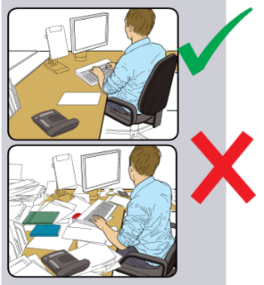  Is the work surface large enough for all the necessary equipment, papers, etc.? |  |  | Create more room by moving printers, reference materials, etc. elsewhere. If necessary, consider providing new power and telecom sockets, so equipment can be moved. There should be some scope for flexible arrangement.
Can you comfortably reach all the equipment and papers they need to use without over-reaching, twisting or stretching? |  |  | Rearrange equipment, papers, etc. to bring frequently used thing within easy reach. A document holder may be needed, positioned to minimise uncomfortable head and eye movements.
Are surfaces free from glare and reflection? |  |  | Consider mats or blotters to reduce reflections and glare from Campus Services.
How suitable is your chair?  Does the chair have a working:  Seat back height and tilt adjustment?  Seat height adjustment?  Swivel mechanism?  Castors or glides?  Arm rests? |  |  | The chair may need repairing, adjusting or replacing.
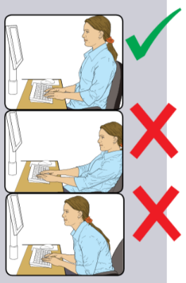  Is the chair adjusted correctly? |  |  | The user should be able to carry out their work sitting comfortably. The arms of the chair can stop the user getting too close to the equipment. Any obstructions should be moved from under the desk.
Is the small of the back supported by the chair’s backrest? |  |  | The user should have a straight back, supported by the chair, with relaxed shoulders.
Are forearms horizontal and eyes roughly at the same height as the top of the VDU? |  |  | Adjust the chair height to get the user’s arms in the right position, then adjust the Visual Display Screen Unit (VDU) height, if necessary.
Are feet flat on the floor, without too much pressure from the seat on the back of the legs? |  |  | If not, a foot-rest may be needed.
- Environment
Is there enough room to change position and vary movement? |  |  | Space is needed to move and stretch. Consider reorganising the office layout and check for obstructions. Cables should be tidy and not present a trip or snag hazard.
Is the lighting suitable, i.e. not too bright or too dim to work comfortably? |  |  | Users should be able to control light levels. For example, adjusting window blinds or light switches. Consider shading or repositioning light sources of providing local lighting, e.g. desk lamps (but make sure lights don’t cause glare by reflecting off walls or other surfaces).
Does the air feel comfortable? |  |  | VDUs and other equipment may dry the air. Circulate fresh air if possible. Plants may help. Consider a humidifier if discomfort is severe.
Are levels of heat comfortable? |  |  | More ventilation or air-conditioning may be required if there is a lot of electronic equipment in the room.
Are levels of noise comfortable? |  |  | Consider moving sources of noise, e.g. printers, away from the user. If not, consider sound proofing.
- Other
On average, how many hours do you spend using display screen equipment per day? | Hours |  | Long periods of work without a change in activity will increase the risk. Adverse symptoms may develop even if the work environment and other conditions are good.
Do you have any aches, pains or discomfort while using the display screen equipment? |  |  | Any muscular pain or discomfort should be reported to either a GP or Soma Occupational Health.
Are you aware of the policy on eye examinations? |  |  | Please refer to the Health & Safety pages for further information: https://www2.worc.ac.uk/facilities-staff/display-screen-equipment.html
Do you have regular changes in activity? |  |  | Recommend frequent short breaks rather than longer more infrequent breaks. Encourage fidgeting, change of focus and other activities away from the DSE.
Do you have any other problems relating to the work? |  |  | Psychological factors (poor control over the work, poor support from managers/colleagues, boredom, work overload and external problems, etc.) can be significant factors in the development of some musculoskeletal disorders.
Can you use the telephone comfortably? |  |  | Avoid cradling the telephone between the neck and shoulder. If using the phone for long periods use a headset.

Information for Line Manager:
Once the Display Screen Equipment Assessment Form has been completed by the staff member, they will return it to you. You will then forward this to the HR team (hr@worc.ac.uk).

If there any issues or concerns arising from the self-assessment, the HR Business Partner for the area will refer the case to either an internal DSE Assessor (there are several people trained to undertake assessments), or to the external Occupational Health Service.

Any adjustments required (e.g. Chair, screen, keyboard, mouse) will need to be ordered through the normal departmental procurement procedures.
Use this section to highlight key issues or concerns:

