Note:

Brief description of the activity being assessed
The SU elections will be coming up and we are at having an event on Union Square on Wednesday of voting. We will have a number of activities with the main attraction “surf simulator” (inflatable). I have attached images, and insurance.

Title of Assessment: | Use of Inflatable /Bouncy Castle | People involved in making this assessment: | Student Union  Names:-
Risk Assessment Reference & Version | SS01 V1 | Date of Assessment: | Date …………
Risk Assessor (Name & Position) | Name of assessor | Date of Review | Note Annually or If changes are needed due to a change in the business operations
Approved by: (Head of school / Head of department)  Date: Date signed off. |  | Process of communicating to relevant persons  Information will be shared in the Team Meeting to all staff.

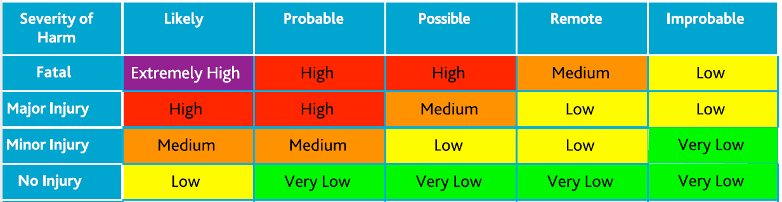
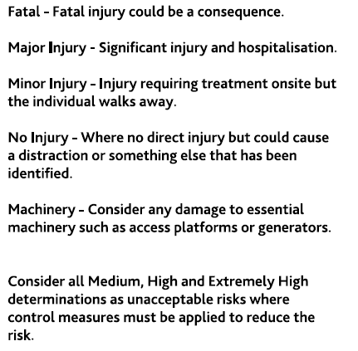

Hazards  (A hazard is something that can cause harm, e.g. electricity, chemicals, working up a ladder, noise, car, DSE, | People at Risk  (Students, Staff, Visitors, Contractors, Other) | What harm might occur,  (Slips Trips, Falls, Breaks, Sprains etc…) | Control Measures already in place  (Control measures include actions that can be taken to reduce the potential of exposure to the hazard). | Evaluate the Risk  (Having identified the hazards and controls, decide how likely it is that harm will occur), | Additional Control Measures  (Only necessary when additional controls are required.  These controls form part of the standard control measures when implemented.) | Revaluate the risk  By adding the additional controls, has the rating changed?
Electrical extensions or anchorage points | Staff, Visitors | Slip, trips and falls on electrical extension cables Burses, sprains, strains, etc… | 1. The Inflatable /Bouncy Castle is located in a convenient area in close proximity to an electrical outlet.  2. The electrical lead is fed from the rear of the Inflatable /Bouncy Castle away from walkways.  3. Barriers are fitted adjacent to the rear of the Inflatable /Bouncy Castle to prevent people from tripping/accessing the power/extension lead.  4. A portable generator will be used if access to electrical outlets is impractical. | Medium | Anchorage points are positioned away from walkways. | Low
Manual Handling & transporting | Employees | suffer from strains and sprains from incorrect manual handling techniques | 1. Employees have been provided with manual handling training during the induction process.  2. Trolley provided and used for the movement of the Inflatable /Bouncy Castle prior to assembly or after dismantling.  3. Two people will roll up the Inflatable /Bouncy Castle after it has been deflated.  4. Employees to ensure access and egress to the area is clear prior to movement/placement of the Inflatable /Bouncy Castle. | Medium | No Significant Changes, however, under constant review | Medium
Electrical equipment. | Staff, Visitors, Users | electrocution from faulty or damaged electrical Equipment | 1. All electrical equipment is portable appliance tested at prescribed intervals.  2. Employees visually check any electrical equipment for damage prior to use. (e.g. Electrical blower)  3. Employees visually check the extension cables for any damage prior to use.  4. Employees will ensure the electrical outlets are RCD protected if not then utilize the portable RCD available.  5. The electrical blower provided with the inflatable is tested at regular intervals. | Medium | No Significant Changes, however, under constant review | Medium
Impact Injury | Staff/ operators | injury if they hit their hand with the mallet when driving heavy-duty stakes into the ground that will secure the inflatable | 1. Employees have received training and instruction on the installation of the Inflatable /Bouncy Castle.  2. Hold the heavy duty stakes halfway down when driving them into the ground.  3. Employees to be vigilant at all times when knocking heavy-duty stakes into the ground. | Medium | No Significant Changes, however, under constant review | Medium
Inadequate anchorage | Anyone using the inflatable or located near the inflatable | suffer major injury if the device moves or tips during inclement weather | 1. The designer and manufacturer of the inflatable has supplied the information stipulating the amount and type of anchorage points to be fitted when installing the inflatable.  2. Employees follow the manufacturer’s instructions and internal training to ensure adequate anchorage and ballast systems are fitted to the inflatable device being utilized.  3. Employees have been provided with training on the maximum winds speed the inflatable device can be used.  4. The information sheet provided by the manufacturer of the inflatable in use is readily available. (Max wind speed the inflatable can be used, the size, number and strength of anchorage points)  5. All the anchor points used are made up of metal ground stakes at least 380mm in length and 16mm diameter with a rounded top. | Medium | No Significant Changes, however, under constant review | Medium
Inadequate equipment Poorly maintained equipment | Users of the Inflatable /Bouncy Castle | Suffering from various injuries | 1. The inflatable being used is fitted with a label stipulating it complies with British Standard (BS EN 14960)  2. An annual inspection is carried out on the inflatable device.  Accredited with ADIPS or PIPA | Medium | No Significant Changes, however, under constant review | Medium
Access and egress | Users of the Inflatable /Bouncy Castle | Injury when falling from the inflatable when getting on and off | 1. Safety matting fitted at the entrance of the inflatable in case of falls or ejections | Medium | No Significant Changes, however, under constant review | Medium
Entanglement / entrapment | Users of the Inflatable /Bouncy Castle | major injuries from contact with rotating parts of the blower | 1. The area where the blower is running is fitted with adequate fencing to prevent unauthorized access | Medium | No Significant Changes, however, under constant review | Medium
Deflated equipment (Inflatable /Bouncy Castle going flat) | Users of the Inflatable /Bouncy Castle | Suffocation | 1. Shoes, glasses are to be removed prior to accessing the inflatable  2. Person using the inflatable are instructed to remove sharp objects from their pockets.  3. The use of the Inflatable /Bouncy Castle is supervised at all times | Medium | No Significant Changes, however, under constant review | Medium

Action Ref | Action required | Who is responsible? | By when? | Date completed / Comments
1 | Ensure Anchorage points are positioned away from walkways. | Name | Date | Comments and completed by.

