Security and Operations
Service Level
Agreement
Grounds

DOCUMENT CONTROL:....................................................................................................3

1. INTRODUCTION............................................................................................................4
1.1 Scope of the Agreement .....................................................................................................4
1.2 Duration of the Agreement..................................................................................................4
1.3 Signatories to the Agreement..............................................................................................4
1.4 Service Contacts...................................................................................................................5
1.4.1 Professional Services Main Service Desk/Contact Point…………………………………………........5
1.4.2 Professional Services Primary Contact..............................................................................6
1.4.3 Customer Details ..............................................................................................................6

2 SERVICE DESCRIPTIONS................................................................................................6
2.1 Our services agreed to be In-scope of the Service Level Agreement..................................6
2.1.1 Standard Services.............................................................................................................6
2.1.2 Time Allocation Chart…………………………………………………………………………………………………..8
2.1.3 Additional Features..........................................................................................................9
2.2 Our services agreed to be out-of-scope of the Service Level Agreement ..........................9
2.3 Service Coverage.................................................................................................................9
2.3.1 Service Hours/Availability................................................................................................9
2.3.2 Service Eligibility.............................................................................................................10
2.3.3 Service issue escalation..................................................................................................10

3 SERVICE LEVEL.............................................................................................................10
3.1 Target Service Levels.........................................................................................................10
3.2 Monitoring our performance............................................................................................12
4. CUSTOMER RESPONSIBILITIES ..................................................................................14

5. MANAGEMENT OF SERVICE LEVEL AGREEMENT.....................................................14
5.1 Governance and Review of Service performance.............................................................14
5.2 Service Issue Escalation.....................................................................................................14
5.3 Change control..................................................................................................................15

Enclosure: Campus Map

Document Control:
Project/Service Name: | Security and Operations
Document Number:
Document Category: | Service Level Agreement
Issued By:
Version | Reason for Change | Author | Date
0.1 | Review | Security and Operations | 2015
0.2 | Review | Security and Operations | 2019
0.3 | Review/New sites | Security and Operations | 2022
0.4

Distribution for Approval:
Title | Name | Signature | Date

Distribution for Information:
Department | Title | Name | Date

1 Introduction
This document defines the service agreement between Facilities (Campus Services) and Institutes and Professional Services Departments of the University of Worcester, to provide a Grounds maintenance service.

1.1 Scope of the Agreement
The agreement covers the implementation of routine maintenance of the University’s grounds, as well as providing both planned and reactive maintenance, to ensure that the grounds are maintained in a safe and tidy manner to the satisfaction, safety and enjoyment of students, staff and visitors.

1.2 Duration of the Agreement
This agreement is open ended, i.e. it remains in operation indefinitely unless withdrawn or superseded.

1.3 Signatories to the Agreement
The signatories to this agreement are:

Area / Location | Responsibility
Area 1 (Red)  Avon/Ledbury/Pershore/Smoking  Area/Thomas Telford Rear | Security and Operations
Area 2 (Blue)  Halls 16 blocks  Worcester Halls Front & Rear AEH/EBB/Orchard | Security and Operations
Area 3 (Orange)  Bredon Front/ Fern Court/ Rear Bredon/ Bredon Car Park/Crèche | Security and Operations
Area 4 (Green)  Severn Gate/ Henwick Houses/ 3G surrounds | Security and Operations / Sports Centre/ Biodiversity Group
Area 5 (Yellow)  Sheila Scott Front and Rear | Security and Operations / Oldbury Park School/ Snoezelen/ Forensics
Area 6 (Brown)  Charles Darwin Front/ Binyon North & Main/ Costa Quad/ Side of Sand Filled Astro/ Wisteria Quad/ Hines Front | Security and Operations /Comms & Part
Area 7 (Pink)  Woodbury Front & Rear/ Secret Garden | Security and Operations / Forensics
Area 8 (Purple)  Malvern Gates Surrounds/ Pierson Surrounds/ Front Reception/ SU Front/ Conference Car Park | Security and Operations /Comms & Part/ VC office
Area 9 (Grey)  Conservation Area/ Rear of Pollen/ Rear of Science Labs | Security and Operations / Science/ NPARU
Area 10  Jenny Lind | Security and Operations / Accommodation
Area 11  Hylton Road Garage/ Storage/ ETB | Security and Operations
Area 12  Riverside/Arena | Security and Operations / Comms & Part / Sports Staff
Area 13  Moors Playing Fields | Security and Operations / Sports Staff
Area 14  City Campus whole site | Security and Operations / Sports Staff/Comms & Part/ Business School
Area 15  Art House | Security and Operations / Accommodation
Area 16  Battenhall Football Fields | Security and Operations / UW Sports Staff/Nunnery Wood FC
Area 17  Lakeside | Security and Operations / UW Sports Staff/ Dominies CC
Area 18  Battenhall Cricket Fields/University Park | Security and Operations / UW Projects Team
Area 19  Managed University Accommodation | Security and Operations / Accommodation Office/ Landlords
Area 20  Severn Campus | Security and Operations / Medical school
Area 21  University Court | Security and Operations / Accommodation Office/ Landlords
Area 22  Events Set Up | Comm’s/Accommodation

1.4 Service Contacts
Listed below are the names, emails and contact numbers of the primary service contacts.

1.4.1 Professional Services Main Service Desk/Contact Point

Telephone Number: Facilities  Monday – Friday: 08:00 – 16:00 | 01905 54 3344
Emergency Number  At all other times | 01905 855000
Web Contact  24 hours, 365 days | www.worc.ac.uk
Email Address | facilities@worc.ac.uk
1.4.2 Customer Details
University Of Worcester
Henwick Grove
WR2 6AJ

2 Service Descriptions
Facilities Security and Operations will provide full grounds maintenance and gardening service to all the University sites. It also covers customer funded grounds works (accommodation only).
Security and Operations will ensure good practises are applied in the upkeep and renewal of grounds and planting techniques, as well as liaising with specialist contractors / sub-contractors where required.

2.1 Our services agreed to be In-scope of the Service Level Agreement
The following range of activities is agreed as being in-scope and will be handled:

2.1.1 Standard Services
The landscape maintenance schedule encompasses all aspects of routine maintenance and will be updated on an annual basis to reflect changes to the estate.
The landscape maintenance schedule incorporates the following set of standards which will be audited against:-

GM1 Grass Cutting – The Grounds team will mow formal grass areas from March to December to maintain a grass height not exceeding 25mm. Wet weather conditions may result in grass exceeding the specified limit; in this case the grass will be cut as soon as practicable. Meadow areas will be cut annually in September / October. As a minimum, grass will be mown every ten working days for fine turf, subject to ground / weather conditions.
GM2 Strimming –The grounds team will strim the edges of mown grass areas, and all obstacles within them, every other mowing cycle.
GM3 Grass Edging – All fine turf lawn edges will be cut on a monthly basis with edging shears or an edging machine, with grass edges reformed on an annual basis.
GM4 Shrub Beds and Planters – All shrub beds and Planters will be maintained, including planting and pruning. Herbaceous plants will be cut back and mulched annually. These areas will be dug over and divided every three years. Bedding plants to specified borders will be changed biannually in May and October. All planting and fences around residences to be maintained to minimise opportunities for concealment of intruders.
GM5 Pruning and Hedge Cutting – The need for pruning depends on the species, age and condition of the plants. The grounds team will prune shrubs annually where identified within the landscape maintenance. Where appropriate to the species, the grounds team will trim hedges biannually in August and September. Overgrown hedges will be reformed during the winter months which could include laying. All planting and fences around residences to be maintained to minimise opportunities for concealment of intruders.
GM6 Tree Maintenance – Pruning and felling will be carried out as necessary. The grounds team will carry out tree inspections annually in accordance with the landscape maintenance schedule to identify potential hazards and resolve accordingly.
GM7 Weed Control – The grounds team will minimise the presence of weeds in shrub beds by mulching, herbicides or hand/hoe weeding.
GM8 Litter Control – Litter inspections will be conducted in accordance with the landscape maintenance schedule. All sites will cleared of litter at least once a week, including high profile areas.
GM9 Leaf Collection – Leaves will be collected and disposed of during autumn months to prevent excessive build up.
GM10 Paths, Roadways and Car Parks (Road sweeping / Cleaning) – Sweeping will be carried out monthly by brush or machine to all pathways, roadways and gullies.
GM11 Turfing/Seeding – This will be done as and when necessary to ensure all areas remain in good condition. Ideal months for this work to be carried out are Autumn and Spring.

GM12 Boundaries – To ensure all boundaries are secure and overgrown areas are maintained regularly. All planting and fences around residences to be maintained to minimise opportunities for concealment of intruders.

GM13 Paths, Roadways and Car Parks (Gritting and Snow Clearance) – In times of inclement weather roads, pathways and car parks will be kept clear and safely accessible as far as practicable for pedestrians and vehicles.
During freezing weather the grounds team will follow the Extreme Weather Policy. They will grit roads, footpaths and car parks in accordance with the Gritting / Snow Clearance Plan (which will be developed and reviewed on an annual basis), which sets out the prioritisation for gritting work.
GM14 Hard Landscaping – Provision of Planned Preventative Maintenance of all areas of hard landscaping to the campus grounds budget dependant.
GM15 - Pitch Marking.
GM16 – Event Tasks.
GM17 – Wildflower areas, Perennial and Annual - Wildflower areas will be cut annually in September / October. As a minimum, grass will be mown twice a year, subject to ground / weather conditions. Where required the areas will be rotavated to allow for seed to germinate.

2.1.2 Time Allocation Chart (Allocation based on staffing x 2)
Area / Location | GM Points | Allocated Time
Area 1 (Red)  Avon/Ledbury/Pershore/Smoking Area/Thomas Telford Rear | 1 – 10 & 13 | 18hrs
Area 2 (Blue)  Worcester Halls Front & Rear/AEH/EBB/Orchard | 1 – 10 & 12 - 13 | 24hrs
Area 3 (Orange)  Bredon Front /Fern Court/Rear Bredon/Bredon Car Park/Crèche | 1 – 10 & 12 - 14 | 6hrs
Area 4 (Green)  Severn Gate/Henwick Houses/3G surrounds/ Main Car Park | 1 - 14 | 12hrs
Area 5 (Yellow)  Sheila Scott Front and Rear | 1 – 10 & 12 - 14 | 4hrs
Area 6 (Brown)  Charles Darwin Front/ Binyon North & Main/Costa Quad/Side of Sand Filled Astro/Wisteria Quad /Hines Front | 1 – 10 & 13-14 & 17 | 10hrs
Area 7 (Pink)  Woodbury Front & Rear/ Secret Garden | 1 – 10 & 12 - 13 | 14hrs
Area 8 (Purple)  Malvern Gate surrounds/ Pierson Surrounds/Front Reception/SU Front/Conference Car park | 1 - 14 | 24hrs
Area 9 (Grey)  Conservation Area/Rear of Pollen/Rear of Science Labs | 1 – 10 & 12 - 13 | 24hrs (Seasonal)
Area 10  Jenny Lind | 1 - 13 | 7.5hrs
Area 11  Hylton Road Garage/Storage/ETB | 4 – 10 & 12-13 | 4hrs
Area 12  Riverside/Arena | 1 - 14 | 8hrs
Area 13  Moors Playing Fields / Car Park | 1 – 2 & 5 – 10 &  12 - 13 | 5hrs
Area 14  City Campus whole site | 1 - 14 | 11hrs
Area 15  Art House |  | 2hrs
Area 16  Battenhall Football Fields | 1 – 3 & 5 - 13 | 12hrs (Seasonal per day)
Area 17  Lakeside | 1 – 3 & 5 - 13
Area 18  University Park and Battenhall Cricket Fields. | TBC | As and when required
Area 19  Managed University Accommodation | GM Points as requested | As and when required
Area 20  Severn Campus | 1 – 14 & 16-17 | 74hrs
Area 21
University Park
Area 22
Events

2.1.3 Additional Features
Supporting ceremonies and other University events / initiatives (e.g. marking out the recreation area, setting up temporary bins etc.). These works will be carried out by agreement with the client and the full cost of these services may be charged to the external client. The Policy can be found at...

2.2 Our services agreed to be out-of-scope of the Service Level Agreement
- Any works related to University Managed Properties.
- Any works at Battenhall are covered by a separate SLA

2.3 Service Coverage

2.3.1 Service Hours/Availability
Work requests can be logged at any time via the University Portal icon on the desktop, or by email to facilities@worc.ac.uk.
Alternatively jobs can be logged by telephone 01905 85 3344, Monday to Friday 8am to 4pm.
The majority of routine maintenance is carried out during core working hours, which are Monday to Friday between 8.00am and 4.00pm, but work is sometimes planned outside these hours to reduce disruption or shorten timescales.
Emergency requests can be logged 24 hours per day throughout the year via the reception number which is 01905 855000.

2.3.2 Service Eligibility
This service is provided to all staff, students and visitors of the University.

2.3.3 Service Issue Escalation
If there has been a service failure the customer should initially contact the University Portal or Facilities Reception. See contact details in section 1.4.1.
For more details of how service failures will be handled, see section 5.2.

3 Service Level
This section defines the agreed target performance levels between Campus Services and its Customers, for the provision of the service.

3.1 Target Service Levels
For the Standard Services (in 2.1.1) which require a response to a reactive issue or customer request the customer’s satisfaction with the service is often related to the speed of response and the time which elapses before the problem is fixed. Therefore Grounds will aim to deal with these issues within the Target Response Times below.
Response Time means the time from receipt of the request by the Facilities Team until an initial inspection and, where appropriate, temporary repair has been completed. In some cases an ‘initial inspection’ can be carried out by discussion with the customer without a site visit.

Completion Time means the time from receipt of the fault report by the Facilities Team until a long term repair or partial/complete replacement has been carried out.

Working Hours means hours which are within the Core Working Hours (8.00am and 4.00pm Monday to Friday), and Working Days is construed accordingly.

Target Response Times

Priority | Response Time | Examples
Priority 1 - Emergency | Action work - immediate response  Attend site - within 1 hour (normal working hours*)  Attend site - within 2 hours (other times, this could be carried out by a sub-contractor) | A request is deemed an emergency where a person’s safety or building structures are in danger, such as:  - Tree’s falling on roads/footpaths  - Tree’s falling on buildings  - Clearing of footpaths in severe snow conditions or icy weather  - Flooding
Priority 2 – Urgent | Attend site - within 2 hours (normal working hours*)  Attend site - within 6 hours (other times, this will be carried out usually by a sub-contractor) | Examples of requests deemed urgent could be :-  - General access requests (clearing blocked entrances/exits)  - Event requirements (grass cutting)  - Road/footpath closures  - Clearing of non-priority areas for Snow/Ice (i.e. Halls)  - Securing boundary fences
Priority 3 -  Non Urgent | Attend site - within 24 working hours  Work Completed – within 3 days | Examples of requests deemed non-urgent could be:-  - Grass Cutting  - Overgrown shrubbery preventing access for contractors  - Overhanging branches  - Requests from community users of sports facilities including requests from sports centre.  - Planting  - General public requests (boundary issues)  - Pitch marking on sports facilities
Priority 4 -  Minor Improvement Works | Attend Site - within 14 days to assess the work requirements.  Work Completed - within 4 weeks | Examples of minor improvement requests could be:-  - Fence erecting  - Renovation clearance  - Planting  - Tree pruning  - Laying of pathways/Hard Surfaces  - Hedge cutting  - Turf laying  - Renovation after building projects
Priority 5 -  Major Improvement Works | All works subject to prior feasibility study by the Facilities grounds team and approval from relevant Head of Department.  Contact Thomas Taylor (Assistant Director of Security and Operations), Alan Box (Head of Grounds) and Helen Proctor (Head of Security and Operations). | Examples of major improvement requests would be :-  Re-generation of open space, (e.g.Lakeside) which could include sub-contract labour covering multi-disciplines. This will ensure the following:  - There is no impact on wider services and other departments.  - Budgets for improvement works are funded separately and are not part of the Grounds budget.  - Works can be procured correctly  - Health & Safety procedures are followed throughout the project
3.2 Monitoring our performance
This section details how service levels will be monitored and how performance data will be provided to customers.

A set of Performance Indicators has been defined, and for each indicator performance will be monitored monthly, unless otherwise stated.

Any future performance data will be used as a management tool within Facilities, to identify areas of strong and weak performance, provide information and guidance to Facilities staff, and support planning for future improvements.

Performance review meetings will be held as and when necessary with key Customer Representatives, to provide an opportunity to:
- discuss actual performance versus target
- consider corrective actions where service is below the expected level
- consider any matters escalated to Stage 3
- consider fulfilment of the Customer’s Responsibilities and any issues arising from this
- Consider other relevant topics, including future requirements.
Grounds Maintenance Services SLA –Schedule of Performance Indicators
Ref | Service Name | Performance Indicator | Service Level Agreement
GM1 – 12  GM13 | Routine Maintenance / Client Requests  Reactive Maintenance | GM Delivery of routine maintenance  GM13.1 Response to urgent works  GM13.2 Response to non-urgent / client requests | 90% of GM1-12 as programmed above to be met in agreed timescale
90% of urgent reactive works completed within the designated timescale

90% of non-urgent / client requested works responded to within the designated timescale
GM 14 | Hard Landscaping | Planned Preventative Maintenance | Budget Dependant

4. Customer Responsibilities

To report defects to the Facilities as soon as possible, especially if there is a risk to the health or safety of staff, students or visitors.
To inform the Facilities as soon as possible if it appears that Grounds staff or contractors are working in an unsafe way.
Not to remove or interfere with materials, equipment, signage or other items placed on site by Grounds Staff or its approved contractors.
Not to carry out any Grounds Maintenance works or to instruct contractors to carry out such works, but to request all works from the Grounds Staff.
To provide access promptly when maintenance is required in a space controlled by the customer.
To assist in providing an efficient and effective service, clients are requested to provide the follow the portal instructions to provide the correct information.

5. Management of Service Level Agreement

5.1 Governance and Review of Service performance
This Service Level Agreement will be reviewed on an annual basis, by Security and Operations representatives (Thomas Taylor and Helen Proctor) with at least two Customer Representatives. Checks will be made to ensure that key details are up to date including:
- scope of services within the SLA
- list of customers
- contact details for service provider and customers.

Actual performance levels will be reviewed and target service levels will be adjusted if appropriate.
The landscape maintenance schedule referred to within item 2.1.1 will be reviewed and updated on an annual basis, to incorporate any changes to the estate.
If any changes are required the Head of Security and Campus Services will be asked to approve them and will issue an updated SLA to each of the signatories.
5.2 Service Issue Escalation
If a customer is dissatisfied with the service provided under this SLA the customer may register a formal complaint using the procedure set out below.

Stage 1
The customer should contact Facilities to report the service failure and request an update, which will be provided within 2 working days. (If satisfied, no further action required).

Stage 2
Via Facilities the customer should ask the line manager responsible for the service for a more detailed response to the query, which will be provided within 5 working days. (If satisfied, no further action required).

Stage 3
The customer should consult with their direct line manager who may, via Facilities, request a written response which will be provided by the Director of Estates and Facilities within 7 working days.
To clarify, Stage 1 to Stage 3 should be completed within 7 working days in total.

5.3 Change control
This document will have version control and will be approved by the Head of Security and Operations. It include the date of the agreed amendment, a description of the change, the author and agreement of the Director of Estates and Facilities.

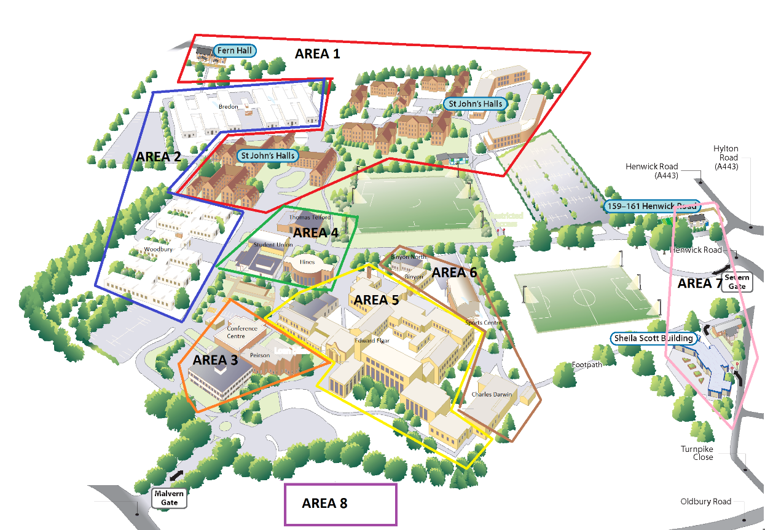
Area 20 Severn Campus
