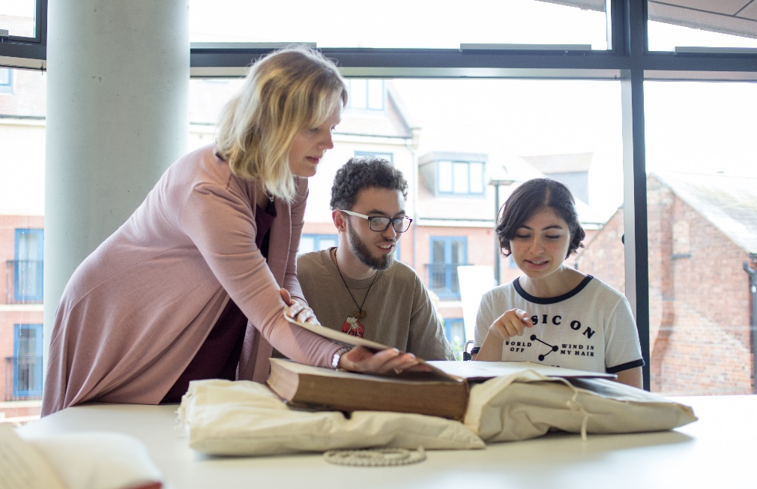

A1.1 Being inclusive in designing and planning teaching and learning activities

Anticipate diversity

How?
Consider each of your activities and overall outcomes from the perspective of students from diverse backgrounds with a range of learning needs.

Why?
This reduces the need to make individual adjustments for students and increases overall student satisfaction.

Know your students

How?
Get to know the backgrounds and interests of your students to inform the activities you choose.

Why?
Activities and materials that are culturally and personally relevant will be more engaging and are likely to promote deeper understanding.

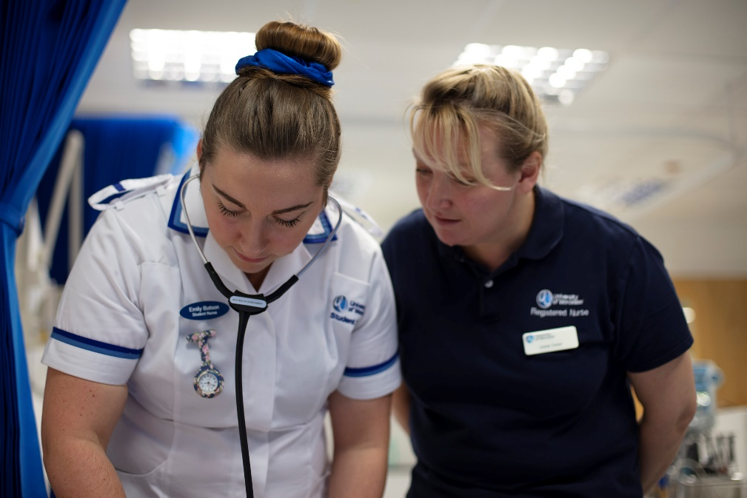

Check students’ skills

How?
Consider conducting a skills audit to identify your students’ learning needs. Remember that some international students may be learning the course material at the same time as developing their English language skills. See the resources on the University’s Study Skills webpages for students, including the quick skills check.

Why?
Knowing your students’ levels of proficiency in numeracy, IT and written English can help you to avoid making assumptions and ensure students are supported to develop the skills they need.

Check assumptions about prior learning

How?
Don’t assume prior knowledge of what you think students should know unless it’s something you have covered previously in the course. Be aware of knowledge that is implicit within your subject and make this explicit where needed. Provide additional study materials or references to help student plug gaps.

Why?
Students will have a variety of prior educational, cultural and social backgrounds and may not all be at the same starting point.

Make materials available in advance

How?
Update content to be used in taught sessions on the VLE in advance and ensure students know when this will be done. Use Advance HE’s guide to flipped learning to learn more.

Why?
Students learn at different paces and student abilities vary. Some students will struggle to read quickly during the session and this will exacerbate anxiety and reduce opportunities for full engagement. Students with specific learning difficulties (SpLDs) may prefer to print off materials in advance rather than reading them from a screen. Students who do not have English as a first language may want to review lecture material beforehand. Flipped learning allows all students to gain basic knowledge before the session and encourages active, rather than passive, learning.

Link to previous learning

How?
Ensure that students know how any newly presented content links to previous knowledge. Recap what you have covered at the end of a session.

Why?
This will help to further embed knowledge and give students a deeper understanding of the wider context. It is particularly useful for some students who are on the autism spectrum or who have SpLDs.

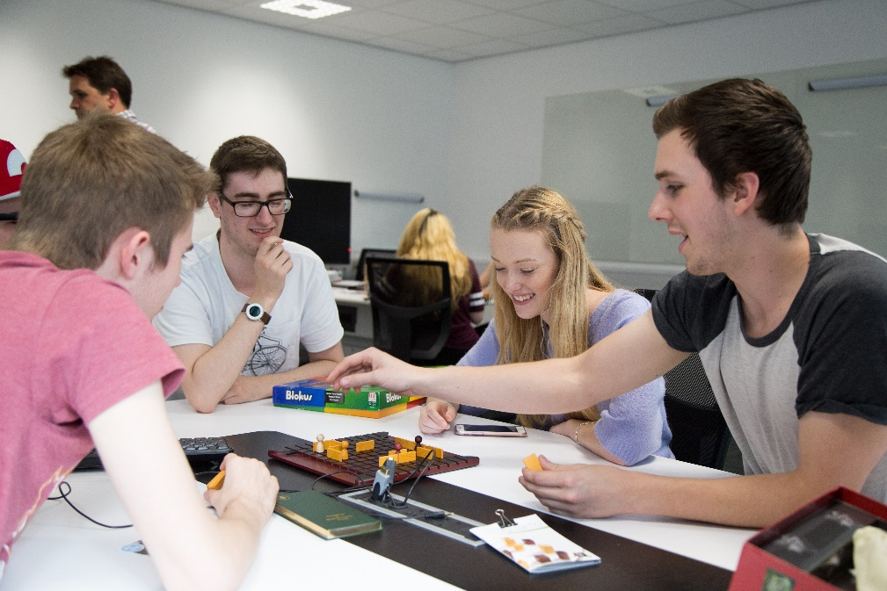

Vary learning activities

How?
Consider interactive, visual, auditory and kinaesthetic materials and activities. Don’t assume that all students will learn from materials in the same way.

Why?
Your student body will include learners with a variety of learning needs and preferences. See the SCALE resources developed by the University of Worcester for detailed information on supporting students with disabilities.

Make learning active

How?
Design learning activities which enable students to discuss, share, explore and apply their understanding and skills, especially in relation to linking theory to practice and applying learning to real world problems. Avoid learning activities where students passively receive information.

Why?
Students learn more effectively when they are engaged in actively applying their learning and linking theory to practice. This also helps them to recognise the provisional and contested nature of much knowledge in higher education and draw on a range of perspectives.

Make your Blackboard site easy to navigate

How?
Ensure your Blackboard site makes use of the built-in organisational features that make it easy for students to locate the materials they need. Keep the content up to date. Use Blackboard Ally to check that your site is accessible and ask students to suggest improvements.

Why?
Making sure that your Blackboard site is well used, easy to navigate and up to date will help all students, including those who are looking to challenge themselves. It is especially useful for students with disabilities and those who need to spend longer reviewing materials.

Make sure written materials are accessible

How?
Always use a sans serif font, such as Arial or Verdana, and use 12 point as standard. Avoid densely packed pages of text and provide plenty of space and numbering to aid navigation around documents.
Consider providing off-white paper to reduce the glare of black text on white backgrounds. Refer to the Disability and Dyslexia Service’s design and presentation ideas guidance for further ideas.

Why?
Materials will need to be accessed by a wide variety of students with differing learning needs.

Make use of inbuilt accessibility tools

How?
Always use the inbuilt style headings in Word when creating new documents. Microsoft has produced a guide to making Word documents accessible to people with disabilities.
Ensure materials or websites that you are directing students to are accessible for screen reading software, and all available electronically. See the accessibility tab on the TEL Team webpages for further guidance.

Why?
This will enable students with a visual impairment to access the materials via a screen reader without having to request additional transcription services.

Useful links and resources

Blackboard Manual: Blackboard Ally, University of Worcester
Creating an inclusive student learning journey, Jisc, 2021
Creating inclusive subject communities, QAA, 2021
Design and presentation ideas, Disability and Dyslexia Service, 2017
Embedding equality, diversity and inclusion in the curriculum: a programme standard, Advance HE, 2019
Guidance on digital accessibility, University of Worcester TEL Team
How can I be more inclusive? Tips and advice videos for academic staff, University of Plymouth
Student-centred learning and teaching playbook, QAA, 2021

With thanks to colleagues at the University of Leeds and Plymouth University, for allowing us to use and adapt their series of guides
Weblinks reviewed and updated: July 2022
Attribution-Non-Commercial CC BY-SA.
This document 2022, University of Worcester. This work is made available for reuse under the terms of the Creative Commons Attribution-Non-Commercial Share Alike Licence 4.0 http://creativecommons.org/licenses/by-nc-sa/4.0/

