A1.2 Being inclusive in designing curriculum content

Embed learning and academic skills development in the curriculum

How?
Consider how you might embed academic skills development into core modules, especially in the first year. The University’s Learner Journeys Toolkit offers further advice on how skills could be embedded and outlines a teaching menu of library sessions which can be provided to support the learning journey.

Why?
This aids transition into higher education for all students, particularly those from non-traditional backgrounds and those who have not studied for a long time. It reduces the need for students with specific learning difficulties (SpLDs) to seek additional support and refreshes the knowledge and academic skills all students.

Make the curriculum accessible and inclusive for your students

How?
A wide range of students with a broad range of needs will need to access the course. This Advance HE article has case studies on how to develop an inclusive curriculum. UCL has produced an ‘Inclusive Curriculum Healthcheck’ which could help you to reflect on how inclusivity is embedded in your curriculum.

Why?
These principles reflect equality legislation and tie in with the ideas behind Universal Design for Learning so that accessibility for all is built into modules from the start.

Make your curriculum globally and culturally inclusive

How?
Include ideas, concepts and reading lists that relate to global communities including those that are presented by different genders, ethnicities and those with different values and beliefs. Ensure the curriculum reflects a range of perspectives and viewpoints where relevant and promotes intercultural perspectives.
Further reading on how this might be done can be found in this Advance HE article, ‘Designing inclusive curricula, teaching and learning’ and in the Times Higher Education article, ‘Decolonising the curriculum – how do I get started?’ This UCL toolkit offers tips on ‘Creating an inclusive curriculum for BAME students’.

Why?
Being able to identify with the material being presented is likely to enhance learning by making it more memorable and relevant. Research shows that this enriches students’ knowledge and understanding of the world, making them more able to understand differing perspectives and improving their problem-solving abilities. It also helps to support the needs of a multicultural and globally mobile student body.

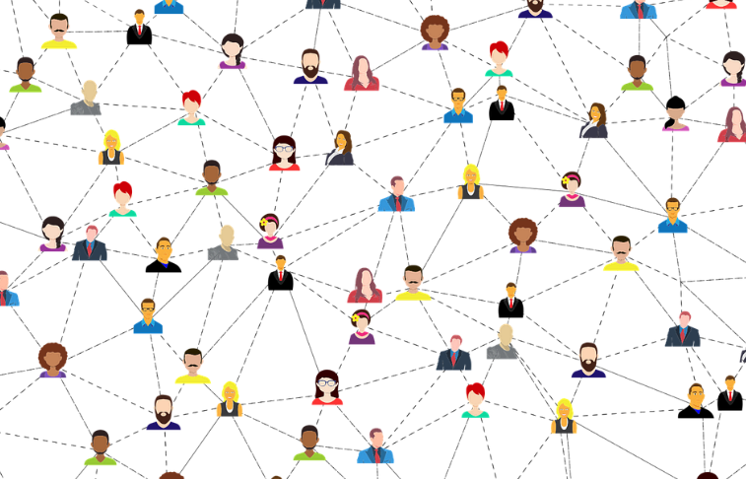

Be culturally and socially sensitive

How?
Avoid activities which might culturally exclude students due to presumed knowledge of Anglocentric or Eurocentric references. Actively challenge cultural norms and stereotypes and use language that reflects this. This guide on ‘LGBT Inclusive curricula’ from the University of Birmingham focuses on inclusivity across the academic disciplines.

Why?
Ensuring all students feel included will provide a more positive learning experience for all. Using examples that people understand will aid their learning and can increase engagement in the curriculum.

Useful links and resources

Creating an inclusive curriculum for BAME students, UCL, 2020
Creating an inclusive learner journey, Jisc, 2021
Creating inclusive subject learning communities, QAA, 2021
Curriculum design, Advance HE
Decolonisation of the curriculum – a conversation, Advance HE, 2020
Decolonising the curriculum – how do I get started? Times Higher Education, 2021
Designing inclusive curricula, teaching and learning, Advance HE, 2020
Inclusive curriculum, Advance HE
Inclusive Curriculum Healthcheck, UCL, 2018
LGBTQ inclusive curricula, University of Birmingham, Advance HE, 2017
Universal Design for Learning, CAST

With thanks to colleagues at the University of Leeds and Plymouth University, for allowing us to use and adapt their series of guides
Weblinks reviewed and updated: July 2022
Attribution-Non-Commercial CC BY-SA.
This document 2022, University of Worcester. This work is made available for reuse under the terms of the Creative Commons Attribution-Non-Commercial Share Alike Licence 4.0 http://creativecommons.org/licenses/by-nc-sa/4.0/

