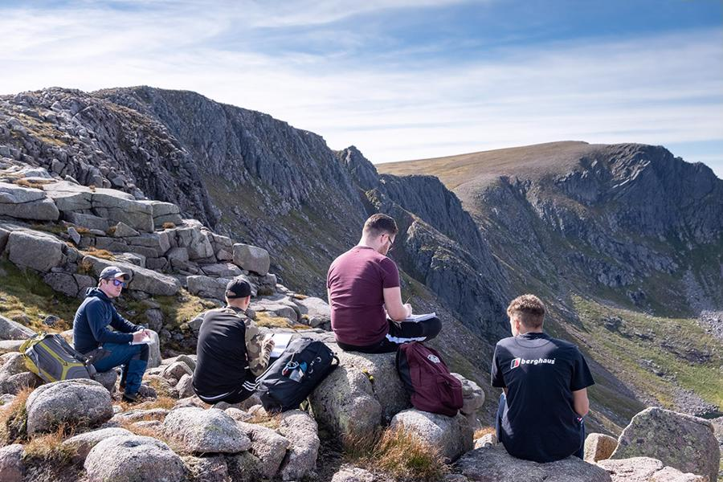

A1.3 Being inclusive in field trips

Introduction
Fieldwork should, as far as possible, be inclusive and accessible. Be mindful of the barriers which may have an impact on student participation and consider how these might be overcome.

Be clear about learning outcomes

How?
Think carefully about how the learning outcomes are being met by the fieldwork and which aspects of the fieldwork could be changed without impacting the learning outcomes. Consider which learning outcomes can only be met by experiencing fieldwork and how the fieldwork could be designed and assessed to ensure it is accessible to a wide range of students while maintaining academic rigour.

Why?
Consideration of learning outcomes informs the fieldwork experience and any adjustments that may need to be made to accommodate different students, such as those with disabilities or specific learning differences (SpLDs).

Check the representation of fieldwork in your course literature

How?
Be aware of how the fieldwork is portrayed in photographs and descriptions in prospectuses.

Why?
Portrayals of fieldwork in prospectuses and promotional material can overly focus on the male, white and physical aspects. This may lead to some students feeling that they will not fit in within this discipline.

Disseminate information

How?
Ensure pre-trip briefings and handouts are accessible to all and that supporting information can be easily found on the VLE. Build in flexibility for individual or small group meetings with students who may have additional requirements.

Why?
Providing clear and detailed information on what will happen on fieldwork is vital. It is important for all students to feel in control of their situation when away from familiar environments and support mechanisms. This is especially true for disabled or transgender students, or those with autism spectrum conditions or mental health difficulties.

Think about food

How?
Ensure that catering facilities can accommodate special dietary requirements. Consider allergies and intolerances as well as vegetarian and vegan diets. Diabetic students may need access to food at particular times to manage their condition and some students may need a fridge for medication. Students may abstain from certain sorts of food or require food to be prepared in a particular way for religious reasons.

Why?
Catering arrangements may be a source of anxiety for some students and they may be concerned that they will not be able to participate if their needs cannot be catered for. It is best if students’ dietary requirements can be accommodated as far as possible as it reduces the need for students to take on the burden of bringing and storing their own food and means they do not feel singled out.

Check if equipment or clothing may be a barrier to participation

How?
Consider whether there may be any safety issues around disability aids (such as wheelchairs or canes) or clothing (such as items worn for religious reasons) and whether these may limit participation in the activity. Discuss this with the students ahead of the trip and work out the best solution. The Disability and Dyslexia Service or colleagues who have run similar trips previously may be able to offer advice.

Why?
Addressing potential barriers ahead of the trip will avoid embarrassment and help the student to understand the rationale behind any restrictions.

Consider accommodation arrangements

How?
Ideally all students will be housed in the same accommodation. However, given the constraints on fieldwork destinations, sometimes it is more appropriate to have additional accommodation available nearby to meet the needs of all students. This may include single rooms for some students and spaces for prayer or religious observance as well as quiet rooms and rooms for socialising. Try to ensure the accommodation is accessible at all times during the trip.

Why?
Some students need quiet environments, e.g., those with anxiety, autism spectrum conditions, mental health difficulties, or medical conditions such as epilepsy or diabetes where a full night’s sleep is part of managing the condition. Other students, such as those who are pregnant or transgender, may have particular requirements relating to accommodation.
Having accommodation which is accessible throughout the trip will provide flexibility if a student needs to remain behind for a day or return early from the field.
Having quiet spaces available encourages students who don’t want to be in loud environments in the evenings to socialise and not just sit in their rooms.

Consider inclusivity in relation to the field trip activities and location

How?
Consider whether socialising activities may inadvertently exclude some students and identify alternatives which include the whole group. Consider issues relating to access to venues and transport for students with physical disabilities.
Build in flexibility for students to work in pairs if the work will involve talking to or interviewing people.
Be aware of religious or cultural sensibilities in the area where the field trip is taking place and prepare students for local attitudes and laws relating to things such as clothing and alcohol consumption. Be aware of additional challenges and discrimination students may encounter in the location, particularly relating to sex, sexuality, gender identity, race, disability or religious beliefs.

Why?
Try to anticipate the needs of the students as they may not always feel comfortable voicing their concerns in the moment.
Many Muslim students may be uncomfortable entering a place where alcohol is served. Try to avoid pubs and bars being the default places for socialising on the field trip. Ensure any spaces used will be accessible for the whole group.
Approaching people may be potentially challenging for students with autism spectrum conditions or mental-health conditions. Working in groups or pairs could help to overcome this.
Students may need information relating to cultural sensibilities where the field trip is taking place. Some students may feel uncomfortable about the destination and would benefit from further support to discuss their concerns.
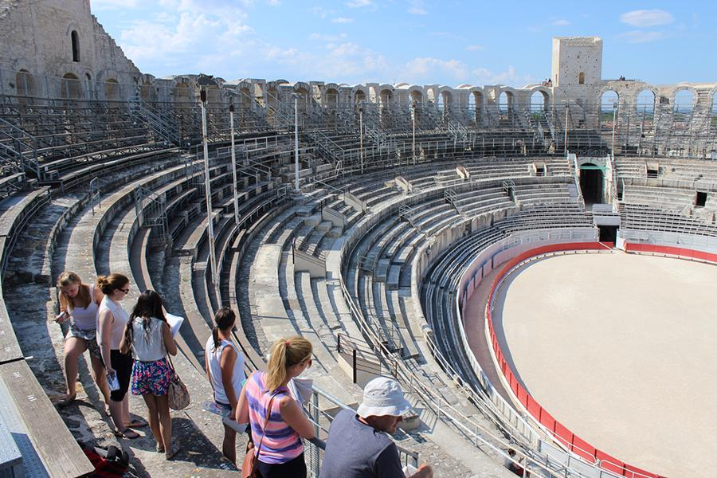

Consider the practicalities of teaching while on location

How?
Try to choose a quiet location for delivering teaching. If this is not possible, hold the introduction and debrief in quieter locations.
Supplement verbal information with written information to limit the amount of note-taking that is required from verbal instructions.
Ensure that there is enough time for students to travel between the different locations used on the field trip.

Why?
A quiet location for teaching is particularly important for students with hearing difficulties or for those with conditions such as dyslexia which make note-taking difficult and time consuming.
Listening and taking notes simultaneously are particularly difficult for some students. Having written information which students can refer back to will help them to take in the information and understand what is expected of them.
Students with limited mobility may miss the beginning of the teaching if not enough time has been allowed for them to travel between locations.

Think about how the schedule might affect certain students

How?
Wherever possible, have clearly defined rest breaks, mealtimes and finish times. Consider how much time will be spent in the field each day and whether it is possible to have flexible working hours. Consider whether it is possible for students to have control over the hours they work. Ensure the schedule is communicated clearly to the students.

Why?
This enables those who need to control their diets, energy levels or medication to make plans in advance. It is also helpful for students who struggle in unfamiliar environments to know what the routine will be. Fieldwork is tiring, especially for disabled students. By building in rest breaks for all students and pacing the working hours, disabled students are not singled out when they need to take a break.

Useful links and resources

Education for Mental Health Toolkit – Field Trips, Advance HE, 2022
Fieldtrips: top tips for academic staff working with students with disabilities, University of Plymouth, 2016
Fieldwork principle 4: accessible and inclusive fieldwork, Royal Geographic Society
Fieldwork and disability: an overview for an inclusive experience, Geological Magazine, 2020
Good practice in inclusive field work, Oxford Brookes University
LGBTQ inclusive curricula, University of Birmingham, Advance HE, 2017
Re-imagining the ‘field trip’ – new and old forms of outdoor learning supporting Education for Sustainable Development, QAA, 2021
Supporting an inclusive learner experience in higher education, Jisc 2018

With thanks to colleagues at the University of Leeds and Plymouth University, for allowing us to use and adapt their series of guides
Weblinks reviewed and updated: July 2022
Attribution-Non-Commercial CC BY-SA.
This document 2022, University of Worcester. This work is made available for reuse under the terms of the Creative Commons Attribution-Non-Commercial Share Alike Licence 4.0 http://creativecommons.org/licenses/by-nc-sa/4.0/

