A1.5 Being inclusive in placements

Review course publicity materials

How?
Ensure publicity information is clear about the requirements of the course. Where possible, describe work-based learning activities and provide video examples of placement settings. Communicate a willingness to consider reasonable adjustments where required and ensure your publicity materials represent diverse groups.

Why?
These materials will help students to envisage the type of activity they may be involved in. This will help students to anticipate any support needs they might have and discuss how these needs might be accommodated with the course team before application.
If applicants do not see themselves represented in the course images or see a commitment to considering reasonable adjustments, they may conclude that they are not a suitable candidate for the course. However, if prospective students with specific needs (such as those with disabilities or faith or cultural requirements) see that they will be welcomed and valued, they will be more likely to consider applying.

Ensure learning outcomes are clear

How?
At the design stage, clarify the purpose of the placement experience, the intended learning outcomes and how these will be assessed. Consider whether requirements of any professional bodies need to be incorporated.

Why?
Placement activities can sometimes require additional skills that are not necessarily going to be assessed. Being clear about what will be assessed will reduce stress for students.

Support students to find placements

How?
Where there is a requirement for students to find their own placements, create a level playing field by sharing and disseminating information about possible placements and industry contacts. Encourage students to speak to the Careers and Employability Service for assistance in identifying potential placement providers and navigating any application processes such as CVs or interviews.

Why?
Some students may face a disadvantage with finding placements due to their background or lack of skills and experience in professional and social networking.

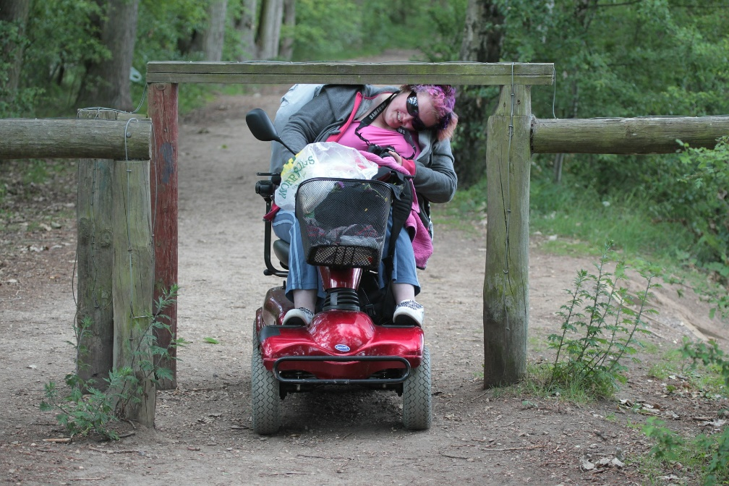

Be prepared for disabled applicants when organising placements

How?
Collect information on placement providers about physical access, transport and working hours. Ensure providers are aware of University policies on equality and diversity and ask that these are respected in reference to placement students. Invite feedback from students about their views on the inclusiveness of their placement experience so that any issues can be addressed in future planning.
Ensure students are aware of the procedure they should follow to disclose a disability or any specific needs. Provide a clear rationale and multiple opportunities for students to make a disclosure. Ensure that there are clear procedures for how the information is shared with those responsible for allocating placements and the placement provider (if the student gives permission). For further information, refer to the University’s ‘Guidance for staff in managing work placements for disabled students’.

Why?
Having information on each placement provider provides a helpful starting point if specific adjustments need to be considered. Where students have been treated unfairly on the basis of protected characteristics, the placement provider should be reviewed. In some cases, it may be appropriate not to use this placement provider again.
Students with disabilities or other specific needs may not have experienced difficulties relating to their studies and therefore may not have deemed it necessary to make a disclosure at the beginning of the course. However, they may need additional support in relation to work-based learning. It is important that students are aware that they can make a disclosure at any point during the course.

Support students to prepare for placements

How?
Embed structured support for placement preparation into the curriculum and promote awareness of University policies and equality legislation both to students and placement providers.
Follow procedures for finding out how disabled students’ support requirements can be met during placement and contact the Disability and Dyslexia Service for further advice. Encourage all students to think through any requirements they may have, such as in relation to religious observance or caring responsibilities, and how they will manage this while on placement.

Why?
Embedding placement preparation sessions into the course ensures that students don’t have to find additional time outside of their normal timetable to attend sessions. This could be problematic for some students, including those who need to work part-time or who have caring responsibilities. University policies should be consistently applied to students’ experience of course requirements so should still apply in off campus learning.
Some aspects of a student’s situation may not have been fully explored during a student’s needs assessment, particularly if the placement is optional. Pre-empting practical or logistical considerations will reduce the need for additional arrangements to be made once the placement has started. Engaging with support services can help to reduce anxiety for the student and provide information for staff arranging placements.

Ensure students know what to do in the case of unforeseen events

How?
Provide clear, readily available information about what to do in case of sickness or emergency.
Provide a safe environment and supportive culture for students to raise any issues of inequality that arise during the placement. Ensure students know who to approach if they encounter any difficulties and that they are aware of formal procedures for raising a cause for concern.

Why?
Setting clear guidelines helps to reduce stress and ensures that students with additional needs, fluctuating medical conditions and / or caring responsibilities know what is required of them.
Students may try to deal with workplace inequality themselves. Students need to be equipped with the knowledge and confidence to address such situations with support.

Useful links and resources

Education for Mental Health Toolkit – Placements, Advance HE, 2022
Enabling student achievement, QAA, 2018
Guidance for staff in managing work placements for disabled students, University of Worcester
How to support students on work placements, Oxford Brookes University
Policy on the management of placement and work-based learning, University of Worcester
Work-based learning, QAA, 2018

With thanks to colleagues at the University of Leeds and Plymouth University, for allowing us to use and adapt their series of guides
Weblinks reviewed and updated: August 2022
Attribution-Non-Commercial CC BY-SA.
This document 2022, University of Worcester. This work is made available for reuse under the terms of the Creative Commons Attribution-Non-Commercial Share Alike Licence 4.0 http://creativecommons.org/licenses/by-nc-sa/4.0/

