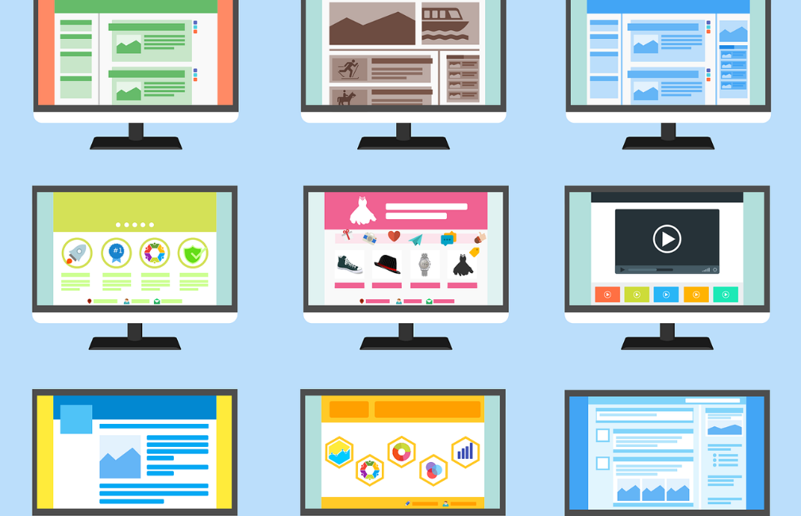

A1.6 Designing inclusive blended and online learning environments

Agree with course team colleagues how you are going to structure your course and module Blackboard sites

How?
Agree a site structure that everyone will adhere to. All Blackboard courses come with an agreed template but there is flexibility to change that. The University has produced guidelines on baseline standards which outline what all students can expect to find on the VLE.
Agree where key documentation will be found across all course modules and how learning technologies such as PebblePad are introduced.

Why?
Students value consistency. For students with a range of learning needs, having to relearn different Blackboard layouts between modules can add to their cognitive load and increase stress.
By having a clear, consistent layout across all the modules in a course, students will know where to find key documents and information. It also reduces workload for staff by reducing the number of enquiries regarding key information.

Ensure your site has a logical layout for screen readers

How?
Using the Blackboard template ensures that students can navigate the learning materials and assessments in a logical fashion. Make sure that any additional links in the left-hand menu are unambiguous. The names of content folders should be self-explanatory: for example, ‘Week 1: Introduction to cakes’, ‘Week 2: Key principles of baking’ rather than ‘Week 1’ and ‘Week 2’.
Use the ‘Student preview’ setting to test how easy it is for a student to navigate the site. For further information, see ‘Accessibility features in Blackboard Learn’.

Why?
Ensuring the menu items are logically laid out and self-explanatory helps visually impaired students navigate the module more easily. Clearly differentiated menu names help direct all students to where they can find relevant module content and activities.

Ensure images have alt-text added

How?
Provide written descriptions (alternative text or alt-text) alongside visuals such as pictures, diagrams or tables.

Why?
Visually impaired students need the alternative text field completed to understand what the image shows.

Make sure that web links are descriptive and open within a new tab or window

How?
When including links to other materials, the link should be human readable text and not the URL itself. The text should describe the nature of the source being linked to. For example, ‘Learn more by visiting the University of Worcester website’ rather than ‘To learn more, click here.’ More information on adding weblinks in Blackboard can be found on the TEL Unit website.

Why?
Screen reader software will announce the presence of a link so a descriptive link means visually impaired students will understand the context of what is being linked to. Opening the external link in a separate window allows the user to be able to continue to navigate the course content.

Ensure web content uses consistently formatted text

How?
Use appropriate styles for formatting web content. Use the Blackboard text editor heading styles to help navigation and use a legible sans serif font, such as Arial, to make text clear. See the British Dyslexia Association’s style guide for further advice.

Why?
Heading styles help visually impaired students navigate web content on your site. Clear, evenly spaced fonts reduce the visual stress for dyslexic students and make content easier to read for everyone.

Check use of colour and colour contrast

How?
Check the contrast ratio of your text against the background using WebAIM’s contrast checker. This should be at least 4.5 to 1. Alternatively, the TEL Unit lists a range of acceptable colours which can be used against a white background. Colour alone should not be used to visually distinguish between textual information. See the TEL Unit’s guide to the use of colour on Blackboard.

Why?
Dyslexic students find reading easier where there is sufficient contrast between the text and background. Colour should not be the only way used to convey meaning as this can pose problems for students with colour blindness and other sight conditions.

Ensure that your Blackboard site and all learning materials in your course are accessible

How?
Ensure all learning materials are accessible, including PowerPoints, Word documents, and any multimedia content. The IT Service has a range of guides on digital accessibility, including using Microsoft accessibility checker tools. To add video and audio captions, see the TEL Unit advice on using Panopto. Use Blackboard Ally to check whether the Blackboard site itself is accessible.

Why?
All learning materials need to be as accessible as possible so that students with a range of learning needs can use them.

Useful links and resources

Accessibility features in Blackboard Learn, Blackboard
Blackboard: baseline standards, University of Worcester
Blackboard Manual: adding web links, University of Worcester
Blackboard Manual: Blackboard Ally, University of Worcester
Blackboard Manual: making your courses accessible, University of Worcester
Blackboard Manual: video and audio, University of Worcester
Blended and online delivery guidance, University of Worcester
Building a taxonomy for digital learning, QAA, 2021
Busy Lecturer’s Guide to Inclusive Practice, University of Worcester
Contrast checker, WebAIM
Dos and don’ts on designing for accessibility, Accessibility in Government blog
Dyslexia Style Guide, British Dyslexia Association
Exploring the impact of Covid19 on disabled students’ experiences, Advance HE, 2021
How to add subtitles or captions to a video, Veed.io, 2021
Inclusive digital practice and digital wellbeing, Jisc, 2021
SCULPT for Accessibility, Worcestershire County Council
Teaching large groups online, University of Worcester
Video captioning and accessibility regulations, Jisc, 2021

With thanks to colleagues at the University of Leeds and Plymouth University, for allowing us to use and adapt their series of guides
Weblinks reviewed and updated: August 2022
Attribution-Non-Commercial CC BY-SA.
This document 2022, University of Worcester. This work is made available for reuse under the terms of the Creative Commons Attribution-Non-Commercial Share Alike Licence 4.0 http://creativecommons.org/licenses/by-nc-sa/4.0/

