A2.1 Being inclusive in lectures

Make teaching materials available in advance

How?
Teaching materials should be made available on the VLE a minimum of 24 hours in advance (longer if possible). Students should be informed when the material will be available for them to view. Provide an outline of the session, learning outcomes and a glossary of new terminology.
Follow good practice guidelines when creating written materials. Use the Design and Presentation ideas guide produced by the Disability and Dyslexia Service to check your materials. Make it clear to all students how they should engage with the materials in advance of the session. If necessary, you can always post a final version after the session.

Why?
A wide range of students, including those with disabilities, will benefit from reading the materials prior to the lecture. Research has shown that advance preparation and contextualisation aids learning.
Making the material more accessible will enable learners to take in the information more quickly and effectively. Students may wish to print off the material or use screen reading software in order to prepare.
Some students may take longer to familiarise themselves with the content of a lecture and understand how it fits into the context of the module. A glossary will help students to learn new terms and see how they are spelt.

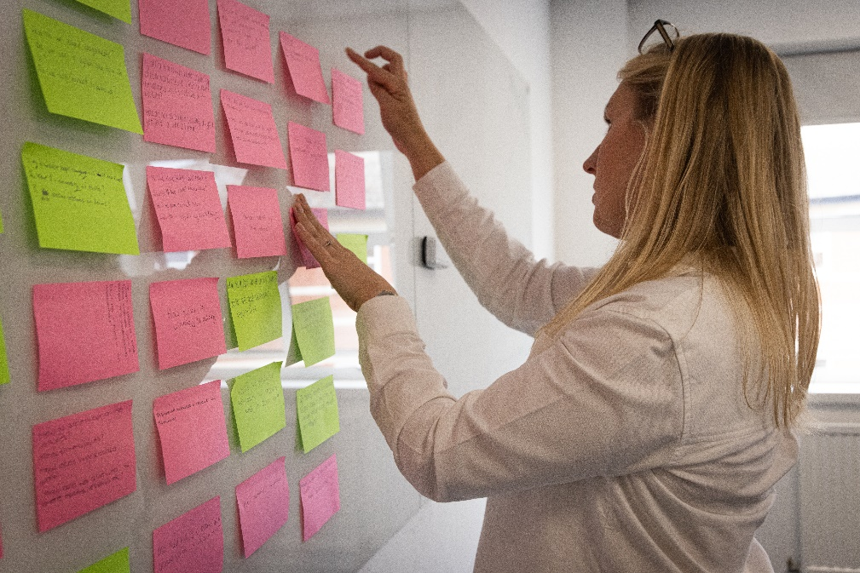

Vary delivery

How?
Avoid ‘death by PowerPoint’: long, monotonous lectures accompanied by never-ending slides. Break up the lecture so that students can actively participate and reflect on their understanding. You can use tools such as online quizzes to test this and identify any issues.

Why?
Varying your delivery is recommended as one of the principles of good inclusive practice in the Universal Design for Learning Framework. Your student cohort is likely to include learners with a diversity of learning styles and active, participative learning is more effective than passively receiving information.

Make PowerPoint slides accessible

How?
Number each slide. Avoid black texts against white backgrounds: cream-coloured backgrounds are preferable. This guide produced by Microsoft suggests good practice guidelines which you can apply to your own slides. Provide written descriptions (alternative text) alongside visuals such as pictures or diagrams.

Why?
This enables students to access materials easily. Some students experience visual discomfort from reading black text on a white background. It is important to ensure that slides can be navigated and read by screen reading software.

Use subtitles in videos

How?
You can use Panopto to add subtitles automatically to your video or create and customise your own. This guide from Veed.io outlines how to add subtitles or captions to your videos.

Why?
This ensures that students with sensory impairments can access the same range of learning materials as all other students. Blind students may miss visual information from videos, so additional descriptions may need to be provided. Deaf or hearing-impaired students may need subtitles to be able to access the aural content.

Ensure clear delivery

How?
Face learners when talking. Speak clearly and use the microphone in larger venues.

Why?
Some learners may rely on seeing your mouth to help them understand what you are saying. Students with a hearing impairment may not always disclose this. Even if you have a loud voice, the acoustics and other noises in the room will affect how much students are able to hear.

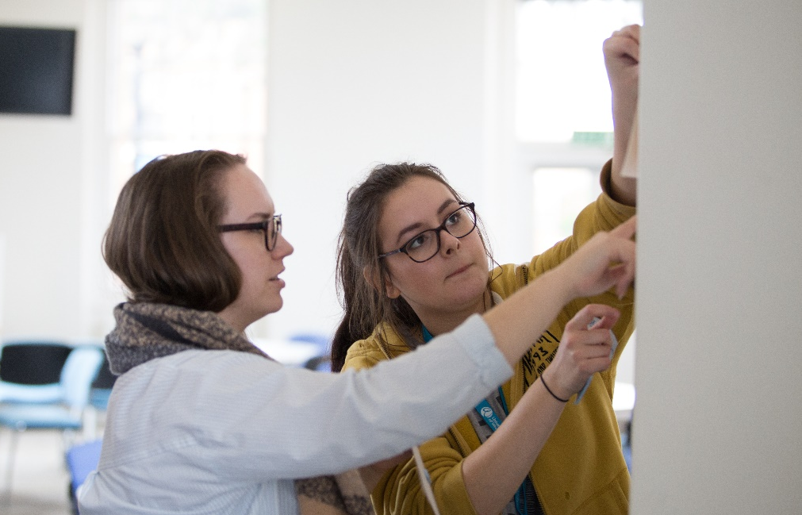

Use signposting

How?
Follow a clear structure and use signposting language to signify different sections and to highlight key points. Explain how each topic covered in the session connects to the next.

Why?
This will help students to take clearer notes and will enable students to navigate materials provided in advance more easily.

Encourage participation

How?
Facilitate communication between students by giving them precise questions or topics to discuss.

Why?
Some students experience social anxiety. Formalising the nature of the communication will help ease anxiety and create structure for the interaction. This also helps students from other cultural backgrounds to initiate communication with others.

Be inclusive in your choice of language

How?
If you use puns, metaphors and colloquial phrases, remember to explain these. Similarly, explain acronyms and abbreviations if these are used in your teaching.

Why?
Some figures of speech may not be readily understood by people with autism spectrum conditions and those for whom English is not their first language. This can cause students to feel excluded.

Be inclusive in your choice of references and examples

How?
Be aware that your audience will include students from a variety of backgrounds with differing levels of UK cultural knowledge. Use a variety of examples and try to avoid being too UK-centric.

Why?
Some references may have little meaning for non-UK students. It is good practice to ensure all students feel the content of the lecture is meaningful to them.

Set ground rules

How?
Agree ground rules of behaviour with your students in terms of talking, use of mobile phones and other mobile devices in the classroom. Remember though that some students make use of their personal devices to record their learning.

Why?
Extraneous noise may be distracting and may interfere with recording devices and hearing loop systems. Set clear expectations to reduce anxiety for those who are uncertain regarding what is or is not permissible.

Avoid last minute changes

How?
Ensure the content matches the materials which have been made available in advance. If it has been necessary to make changes, explain this to the students.

Why?
Some learners will need to prepare in advance and any changes may put them at a disadvantage.

Adjust start and finish times where necessary

How?
Don’t give out essential information at the start of a session if some students have difficulty getting there on time. Make sure you end the session five minutes before the scheduled end time to allow students to get to their next class (as per University convention for use of central teaching space).

Why?
This allows for travelling between the lectures, which may be more difficult for some students than others. It also means that latecomers won’t miss any essential information delivered in the first five minutes.

Evaluate the learning that has taken place

How?
Allow time during the lecture for students to ask questions to consolidate their learning and clarify any points they are unsure of. Alternatively, use post-it notes or online feedback tools such as Mentimeter to ask students to identify any issues or parts of the lecture they are unsure of. Provide an update of the evaluation on the VLE.

Why?
The opportunity to ask questions is important for checking students have understood the content. Not all students are comfortable asking questions in lectures so alternative ways of checking understanding can be more effective.

Useful links and resources

Alternative Text, WebAIM, 2021
Blackboard Manual: video and audio, University of Worcester
Blended and online delivery guidance, University of Worcester
Busy Lecturer’s Guide to Inclusive Practice, University of Worcester
Design and Presentation ideas Disability and Dyslexia Service, 2017
Engaging home and international students, Advance HE, 2013
How to add subtitles or captions to a video, Veed.io, 2021
How to internationalise your teaching: an Advance HE Resource Pack, Advance HE 2022
Making lectures inclusive, University of Oxford
Making your PowerPoint presentations accessible to people with disabilities, Microsoft 2021
SCALE, University of Worcester
Supporting an inclusive learner experience in higher education, Jisc 2018
Teaching large groups online, University of Worcester
Tools for Online Teaching, Mentimeter, 2022
Technology Enhanced Learning Unit Tools, University of Worcester
Universal Design for Learning Framework, CAST 2018

With thanks to colleagues at the University of Leeds and Plymouth University, for allowing us to use and adapt their series of guides
Weblinks reviewed and updated: July 2022
Attribution-Non-Commercial CC BY-SA.
This document 2022, University of Worcester. This work is made available for reuse under the terms of the Creative Commons Attribution-Non-Commercial Share Alike Licence 4.0 http://creativecommons.org/licenses/by-nc-sa/4.0/

