A2.2 Being inclusive in small group teaching

Create an environment of trust and respect

How?
Invite the group to agree ground rules for discussion sessions, such as not talking over each other and putting mobile phones to one side.

Why?
This ensures that students from different educational backgrounds know what behaviour is expected and gives students the opportunity to say what works best for them. Getting students to collectively determine the rules helps them to engage. Mobile phones can be a distraction in the classroom and require protocols for minimising disruptions. By encouraging students to develop the rules themselves, you will improve student engagement and are likely to observe greater compliance.

Consider the setting

How?
Think about the accessibility of the room and how it is arranged to facilitate learning activities. Be prepared to request an alternative room and / or move furniture around where possible. Consider providing alternative quiet spaces for smaller group discussions and / or virtual online space for some activities.

Why?
You need to ensure that students with mobility difficulties and wheelchair users can fully participate in the session’s activities. Students with hearing impairments, attention difficulties, and those who don’t have English as a first language may find it difficult to understand what is being said if there is too much background noise.

Think about how students will take / obtain a record of important points

How?
Depending on the nature of the session, it may be appropriate to permit personal digital recordings. You could take photos of the whiteboard and share with the group via the VLE or appoint students to take and share generic notes.

Why?
Fostering collaborative learning benefits all students. Understanding and anticipating the specific learning needs of students who are disadvantaged in taking notes or information processing is important for students with disabilities or those for whom English is not their first language.

Plan small group discussion tasks

How?
Plan tasks in advance and provide materials to prepare ahead of time. Ask for one student in each group to read the task out to the rest of the group. Encourage all students to engage in group discussion. Plan some questions to ask during the session and encourage group participation in answering these.
Anticipate adjustments required to accommodate disabled students, such as ensuring any handouts are accessible and offering support to students who may struggle to give presentations.

Why?
This provides an opportunity for students to prepare and increases the chance of students contributing. It helps to ensure that all members understand the task before they start and is especially useful for students with specific learning difficulties (SpLDs). Given adequate time to prepare, students will develop their understanding of the topic and feel able to contribute to group discussions.
Group discussions provide opportunities for students to engage better with content, gain a variety of perspectives, and get to know their classmates better. Some students may say very little during classes and may lack the confidence to answer questions posed to them directly. By working in a group, students may gain confidence in voicing their ideas and consequently grow as critical thinkers.

Set clear expectations for group work activity

How?
Explain the purpose of the activity and discuss ground rules. Make it clear what skills and attributes you are assessing and how this links to the module learning outcomes.

Why?
Students from some cultural backgrounds may not understand the value of learning with other students and have little experience of it. Students may worry that they are less well-informed than others in the class or feel that the lecturer, rather than the other learners, should be speaking. Being clear about the rationale for group work and how it links back to the module learning outcomes will help students to understand how they will benefit from the activities.

Assign group members and roles

How?
Assign groups on a randomised basis or pair friends and then combine them to form groups. Try to ensure a diverse mix of backgrounds and personalities. You may want to use your knowledge of the students to allocate roles such as a chair, a note-taker, and a meeting organiser if you think they may struggle to do this. Advise that outcomes from meetings should be recorded in writing by a nominated person and circulated, rather than just agreed verbally.

Why?
This will maximise opportunities to increase students’ global and cultural understanding, as well as their communication skills. In diverse groups it is likely that some students may dominate and others feel excluded. There may also be cultural reasons why some students find certain dynamics challenging. Having clear roles from the outset may help to alleviate some of the anxiety about group interaction and the group dynamics.
Some students may have difficulties taking notes and following conversations where several people are speaking or may have social anxiety which makes it difficult for them to alert others when clarification is required. They may leave a meeting uncertain of the next steps if this is not agreed and clarified in writing.

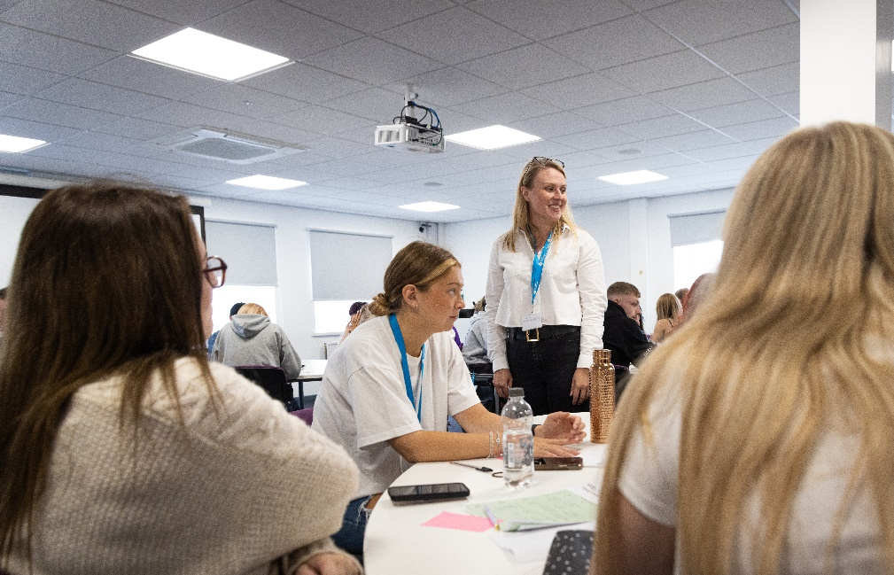

Monitor progress if groups are working together on a project

How?
Ask groups for feedback and updates or monitor their interactions if group work takes place within class time. Ensure students know that they can speak to you about any issues regarding the progress of the group work.

Why?
Early intervention can prevent the group from floundering and ensure misunderstandings are clarified early on. This will prevent them from feeling isolated and you will be able to help resolve any issues if needed.

Encourage disability disclosure

How?
Invite disabled students to speak to you regarding potential issues that may affect communication or participation in group work in advance. The University Disability and Dyslexia Service can provide advice on individual cases.

Why?
This will help you to anticipate adjustments required by your students and help the students themselves feel confident that they will be able to participate in the session. For example, deaf students may need to see other students’ mouths, and may have difficulty with more than one person speaking at once. Students on the autism spectrum may have difficulty with social interaction and may require greater structure. It’s important to help the student to decide whether they want to disclose their disability to the group and, if so, how best to do this.

Useful links and resources

Busy Lecturer’s Guide to Inclusive Practice, University of Worcester
Education for Mental Health Toolkit, Advance HE, 2022
Engaging home and international students, Advance HE, 2013
Hallmarks of Success: student-centred learning and teaching, QAA, 2021
How to internationalise your teaching: an Advance HE Resource Pack, Advance HE 2022
Inclusive and flexible small group teaching, University of Oxford
Inclusive learning and teaching materials, Advance HE
Inclusive small group work, Oxford Brookes University
SCALE, University of Worcester
Supporting students who stammer in higher education, LSBU, 2021

With thanks to colleagues at the University of Leeds and Plymouth University, for allowing us to use and adapt their series of guides
Weblinks reviewed and updated: July 2022
Attribution-Non-Commercial CC BY-SA.
This document 2022, University of Worcester. This work is made available for reuse under the terms of the Creative Commons Attribution-Non-Commercial Share Alike Licence 4.0 http://creativecommons.org/licenses/by-nc-sa/4.0/

