A2.3 Being inclusive in supervising postgraduate researchers

Introduction
Advance HE is clear that the Descriptors of the UK Professional Standards Framework can be interpreted in terms of doctoral supervision. It has produced guidance on how doctoral supervisors can provide evidence for their engagement with the Framework. The Research School has produced ‘Guidelines for Research Degree Disabled Students and their Supervisory Team’ which is intended to support disabled students through their research degree programme. This is available on the Research Degree Programme organisation site on Blackboard.

Foster a culture of inclusion

How?
Ask PGR students whether they have any concerns regarding their studies or anticipate any barriers. Take a holistic view of each student’s situation.
Where appropriate, signpost students to relevant services offered by the University such as the Disability and Dyslexia Service, Firstpoint, the Counselling and Mental Health Service and the Language Centre. Refer to other guides in this Inclusion Toolkit, especially ‘A4.2 Creating Inclusive Learning and Teaching Environments’.

Why?
This approach demonstrates a willingness to appreciate difference and gives PGR students an opportunity to talk about disability or other issues affecting them that may be relevant. PGRs should feel comfortable talking about any issues in a positive context, rather than being made to feel excluded or awkward.
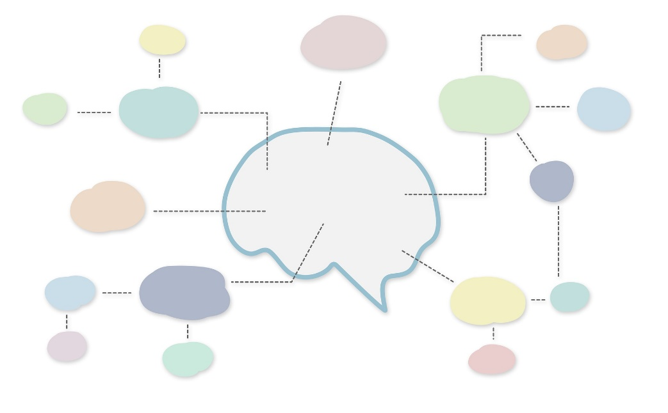

Reflect on your experience and practice

How?
Recognise that individuals will have a range of thinking and learning styles, as well as differing motivations for undertaking a research degree. Your preferred approach to research may not work for your supervisees. Take an open-minded approach and be prepared to adapt to different ways of doing things.

Why?
For example, dyslexic PGR students may prefer to map out their initial ideas visually using mind maps rather than using a linear format. Visually impaired or blind PGRs may opt to verbally describe their ideas rather than using diagrams or graphics.

Be aware of cultural norms

How?
Be aware that the cultural background of a PGR student may affect the student- supervisor working relationship. Be clear about your role and your expectations of a PGR student.

Why?
PGR students from some cultures may take a less critical approach to analysis than is expected in the UK context and may be unused to questioning the ideas of those in supervisory roles.

Work out the best strategies for keeping notes and agreeing actions from meetings

How?
Consider how a disability might impact on note-taking in supervisions. Enable PGR students to concentrate on engaging in discussion and consider allowing audio recording of meetings or providing a bullet-pointed record. Agree on any actions at the end of the meeting so that you have a shared understanding of the next steps.

Why?
Difficulties with memory, concentration, dexterity or specific learning differences (SpLDs) such as dyslexia or dyspraxia may all impact on the ability to listen and take notes at the same time. This means that the act of taking notes may impact on the quality of the discussion. People on the autism spectrum can have a very literal interpretation of language and this may lead to misunderstandings.

Support PGR students with developing planning skills

How?
Assist students with identifying shorter-term and interim goals if necessary to help them to adjust to the requirements of postgraduate research.

Why?
The lack of explicit structure inherent to PGR study can be challenging for many and can contribute to feelings of isolation and a lack of sense of achievement. Difficulty with planning and time estimation are common among students with mental health difficulties and / or SpLDs.

Be aware of PGR students’ mental wellbeing

How?
Undertaking a research degree can be an isolating experience. Ensure students are aware of the services and resources available through the Counselling and Mental Health Service.

Why?
Lack of confidence, uncertainty and isolation can all have an impact on mental wellbeing. During different stages of the process a fear of criticism of ideas can be compounded by insecurities around linguistic abilities, literacy difficulties, educational background and academic writing style. Reassuring your students that there is help available may help to alleviate some of the pressure on them.

Recognise that reading is more challenging for some PGR students

How?
If disabled PGR students use assistive software to access written text, ask them to demonstrate this or try it out yourself to fully understand the process. The library can supply books in an accessible electronic format for students who may have difficulty using a standard text. Students can email disability@worc.ac.uk to request this.

Why?
Being aware of the tools used by your student will help you to understand their working methods and appreciate that some tasks may take longer for students to complete. It will also highlight areas where troubleshooting may be necessary. For example, it may be difficult for the student to make sense of diagrams as these can be tricky to navigate using screen reading software.

Develop good practice in marking and providing feedback

How?
Provide feedback on the content of written work and the quality of the ideas separately from matters of technical accuracy. Be clear about how you have fed back on matters related to technical proficiency in English and direct students to additional support through the Language Centre if required.

Why?
Students with SpLDs, and students whose first language is not English may need additional support to write effectively in English and may need to make use of spell checkers and other software to produce work of the required standard. Remember it is not necessary to mark up every grammatical error; guiding students to proof-read and edit their work will be a more sustainable strategy.

Facilitate engagement

How?
Consider whether there are social and environmental barriers to engagement opportunities, particularly if the PGR student’s disability makes working in shared offices difficult.

Why?
Engagement with peers is an important part of the PGR experience and peer relationships can help to prevent isolation. Fostering an inclusive environment and encouraging students to spend time together helps these relationships to form.

Manage expectations around fieldwork

How?
Assist PGR students early on in thinking through the activities, logistics and time scales of any proposed fieldwork taking into account any constraints the student has. See also ‘A1.3 Being Inclusive in Fieldtrips’.

Why?
Supervisors will have more experience of such activities and be able to ensure the PGR student has a realistic idea of what this will involve and whether it will be achievable for them.

Understand reasonable adjustments

How?
If supervising a disabled PGR student, refer to the University’s Guidelines for Research Degree Disabled Students and their Supervisory Team to ensure compliance when designing inclusive assessments.

Why?
Talking through possible adjustments at an early stage will help alleviate some of the anxiety involved in preparing for a viva.

Useful links and resources

Guidelines for Research Degree Disabled Students and their Supervisory Team, University of Worcester (available via the Research Degree Programme organisation site on Blackboard)
SCALE, University of Worcester
Supervising Master’s Dissertations: A guide to good practice, University of Worcester, 2021
UKPSF Dimensions of the framework for doctoral supervisors, Advance HE, 2020
University of Worcester Assessment Policy
University of Worcester Policy and Procedures for Inclusive Assessment and Reasonable Adjustments
Vitae: Doing research
Worcester Students’ Union: Help & Advice for PGR Students

With thanks to colleagues at the University of Leeds and Plymouth University, for allowing us to use and adapt their series of guides
Weblinks reviewed and updated: July 2022
Attribution-Non-Commercial CC BY-SA.
This document 2022, University of Worcester. This work is made available for reuse under the terms of the Creative Commons Attribution-Non-Commercial Share Alike Licence 4.0 http://creativecommons.org/licenses/by-nc-sa/4.0/

