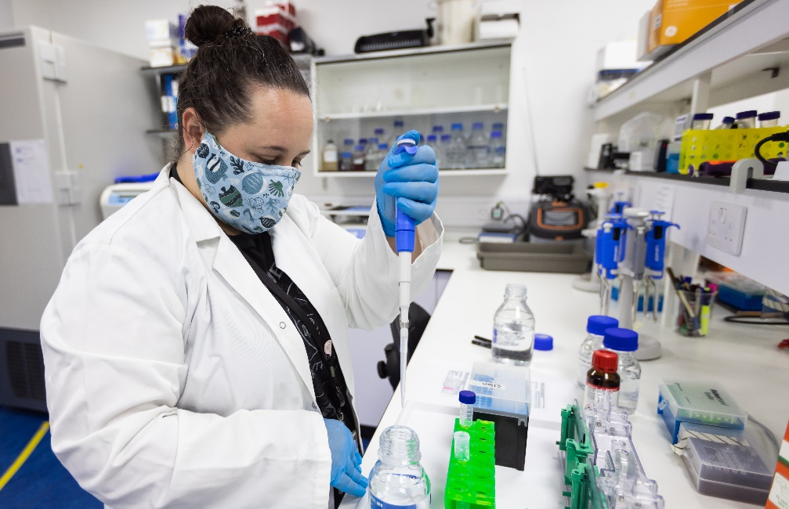

A2.4 Being inclusive in laboratory practical sessions

Anticipate diversity and additional support needs

How?
Include a slide in introductory sessions which gives the name of the person students should speak to if they have any anxieties or specific needs in the lab environment.

Why?
This demonstrates that discussions regarding inclusion and adjustments are welcome and ensures that students know who to approach from the outset.

Teach core skills gradually

How?
Incorporate instruction on basic lab skills into the first year for undergraduate students. Stagger new techniques into different experiments to gradually build up a knowledge base without overloading the students.

Why?
A diverse student cohort means different levels of skills and knowledge. Assuming that students have basic lab skills will mean that some students struggle to benefit from practical sessions. Students may need to be referred back to basic guidance in later years to refresh and embed their knowledge.

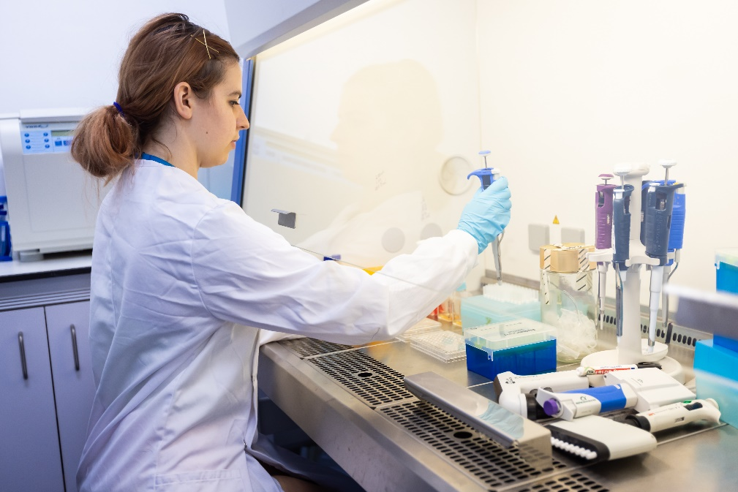

Encourage pre-reading / videos

How?
Publish the introduction for the practical before the lab class and ask the students to interact through formative assessment. Videos of lab work can also help students anticipate what the lab session will involve.

Why?
Students become accustomed to a culture of preparing fully for a laboratory practical. It also gives those who are having difficulty with the material a chance to determine what knowledge is expected to perform the practical experiment competently.

Use verbal and written instructions

How?
Support verbal instructions with written and visual instructions, including diagrams and video, to meet different learning needs. Written instructions should be numbered, clearly spaced out and use size 12 point sans serif font. Further guidance on design and presentation of materials can be found in this design guide from the Disability and Dyslexia Service. These written instructions should be made available in advance.

Why?
Using different modes of instruction will benefit all students and allow them to recap in their own time and take in the information at a pace that suits them.

Ensure the learning outcomes of the lab practical are clear

How?
Provide experimental procedures in advance and list the main aims of the experiments. List the practical skills the student may learn or demonstrate during the activity.

Why?
This allows all students to be certain of the aims and outcomes of the experiments and to have time to read up about procedures and methods they are unsure of. This reduces anxiety and gives students the opportunity to identify in advance whether they will need any additional support with respect to their specific needs.

Give thorough safety training and assess this knowledge

How?
Ensure students take seriously the learning of safety procedures in the laboratory. Highlight aspects of danger and safety.

Why?
While some aspects of laboratory safety seem obvious, learners with some processing difficulties may assess danger in the way you might expect. Assessing this knowledge meaningfully allows the student to gauge the safety of their conduct. This leads to reduced anxiety in the laboratory.

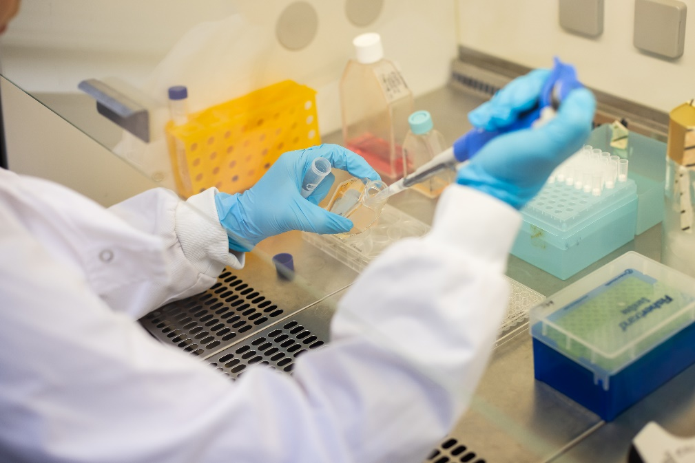

Give a map or diagram showing where apparatus is

How?
If the equipment is not provided at workstations, include both visual and written descriptions of the locations of required equipment.

Why?
Some students need to plan out the whole procedure before the laboratory practical begins. By allowing the students autonomy in finding apparatus, rather than over-relying on demonstrators, stress is reduced in the laboratory.

Consider the number of demonstrators

How?
Where possible, provide more demonstrators or members of academic staff in the first sessions of a laboratory practical.

Why?
In the first sessions, students are often nervous and require reassurance. Ensuring the first session is as stress-free as possible sets a precedent for calm working within the laboratory. Consider balancing the gender mix of demonstrators in the laboratory to facilitate a strong sense of belonging.

Provide timing information

How?
If possible, break the practical experiment down into tasks and give suggested timings for each task where you think this will be useful.

Why?
This allows all students to plan their time effectively, reducing risk of rushing. This skill is particularly difficult for students with specific learning difficulties (SpLDs) and autism spectrum condition.

Provide training and support for demonstrators

How?
Encourage demonstrators to be inclusive in their work and to access resources and training in this area. Shadowing more experienced colleagues can also help.

Why?
Demonstrators may have little prior experience of considering issues of inclusivity in lab settings and may make assumptions about the level of support or assistance that students require.

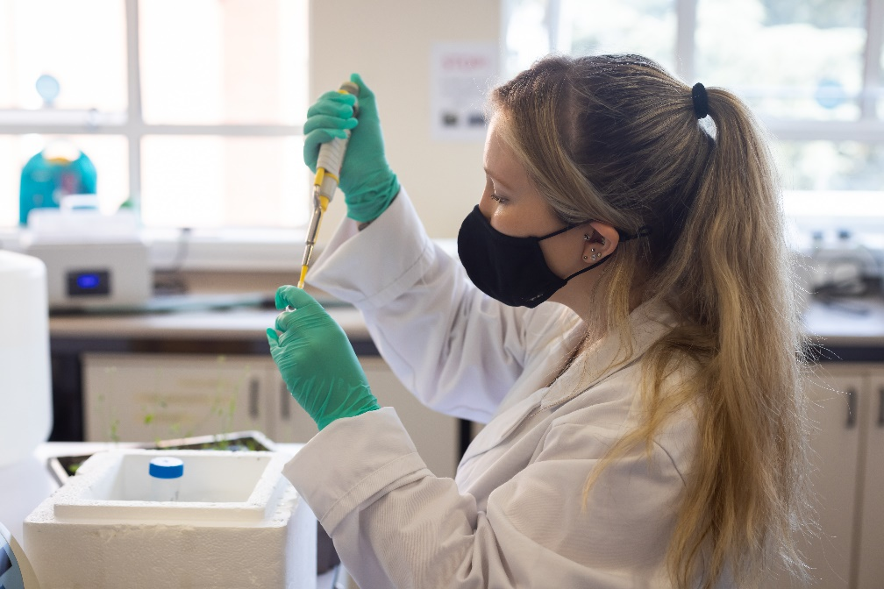

Define apparatus

How?
Unless the task is to be assessed, consider providing a glossary of the names of apparatus with pictures. If the lab is guided, begin the session by naming the equipment in use.

Why?
Some learners find it difficult to remember the names of equipment and may not understand the instructions given to them regarding what equipment to use. This could lead to unsafe practice.

Ensure clarity in demonstrations

How?
Demonstrators need to ensure that they have the attention of all students before speaking, and that all students can see their mouth. Make sure actions and verbal descriptions are explicit.

Why?
Students with hearing impairments will need to watch the demonstration while watching someone speak. They will need time to look at the action. Students with attention difficulties may become easily distracted in busy environments. This helps students’ sign language interpreters or note-takers, or those with a visual impairment.

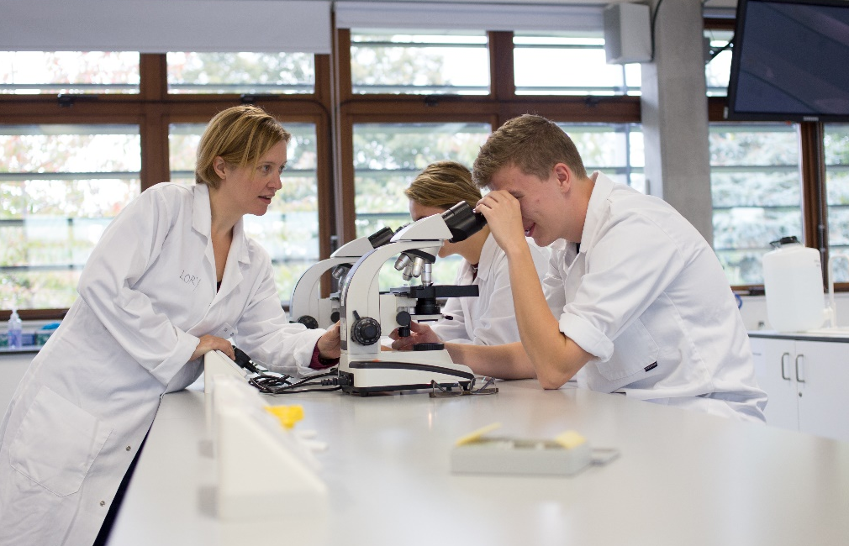

Provide access to resources

How?
Ensure students have access to support and materials for any background knowledge, concepts and skills they may need for the lab.

Why?
Students may be at different starting points or may need additional support to consolidate their understanding of aspects such as maths and basic lab calculations, depending on their learning style and prior knowledge.

Provide guidance for recording results

How?
Give guidance on recording methodology, observations, results and interpretation. Encourage students to develop systems that work well for them, such as creating their own templates.

Why?
Students with organisational difficulties, such as those with SpLDs may not work systematically and risk having an incomplete record of the lab session.

Provide guidance for lab reports in early stages

How?
Give clear information and examples about the format, layout and expected content of lab reports, ensuring that students can easily refer to this guidance when required.

Why?
Some students have difficulty organising information in a linear sequence and may have no prior experience of writing lab reports.

Useful resources

Design and presentation ideas, Disability and Dyslexia Service
Designing inclusive lab practicals, University of Oxford
A dynamic laboratory manual, Higher Education Academy, 2015

With thanks to colleagues at the University of Leeds and Plymouth University, for allowing us to use and adapt their series of guides
Weblinks reviewed and updated: July 2022
Attribution-Non-Commercial CC BY-SA.
This document 2022, University of Worcester. This work is made available for reuse under the terms of the Creative Commons Attribution-Non-Commercial Share Alike Licence 4.0 http://creativecommons.org/licenses/by-nc-sa/4.0/

