A4.2 Creating inclusive learning and teaching environments

Anticipate diversity

How?
Assume that your students will come from a variety of socio-economic, cultural and linguistic backgrounds, and include disabled students who may or may not have disclosed a disability to the University. Avoid making assumptions about gender, sexuality, beliefs and values. The Education for Mental Health toolkit from Advance HE offers resources and case studies on how the curriculum can support wellbeing and learning. It has guidance and resources focusing on inclusivity with regard to race, sensory impairments and LGBTQ+.

Why?
Planning teaching for a diverse group will ensure that the vast majority of students will benefit from your teaching methods, and it will reduce the number of students who may feel left out or marginalised. You will also need to make fewer one-off adjustments for students with common disabilities such as dyslexia.

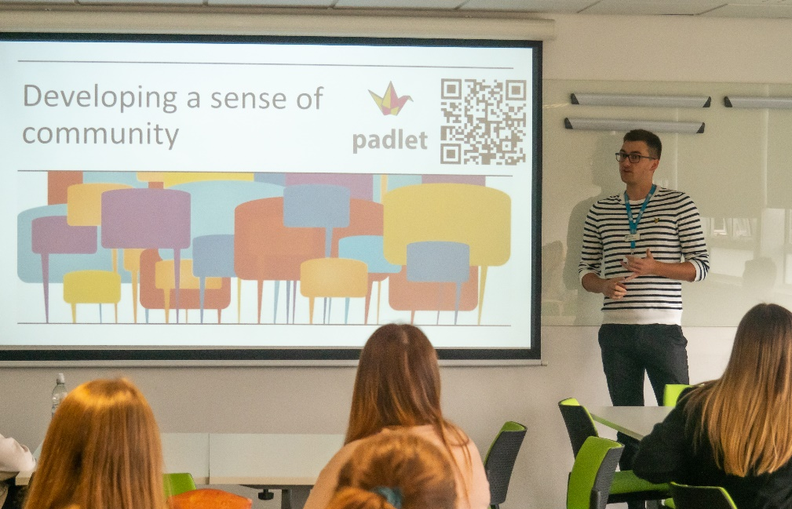

Ensure learning materials are accessible

How?
Check the accessibility of online content and websites before recommending them to students. The SCULPT guidelines from Worcestershire County Council highlight areas to consider and how you can apply these principles to your own teaching materials. Further information on designing for accessibility for different conditions can be found on the Accessibility in Government blog, or via the TEL pages on accessibility.

Why?
Not all texts are accessible. Students who use screen readers and text-to-speech software may find it difficult to read texts which have been photocopied and scanned onto the VLE and will therefore be at a disadvantage.

Make good use of Blackboard and other learning technologies

How?
Make sure your Blackboard site is organised and accessible – make use of Blackboard Ally to check accessibility. Consider how students with different disabilities will engage with learning tasks that involve different technologies. This University guide to teaching large groups online has some tips on how to use technology in your planning and delivery.

Why?
This will lead to a more flexible delivery where students can be more actively involved rather than being passive recipients of knowledge. Including audio, visual and interactive formats will enhance learning for a large number of students.

Create a friendly atmosphere

How?
Get to know your students, by name if possible, and help them to get to know one another. Develop a sense of learning community built on collaboration and partnership, trust and respect.

Why?
A welcoming atmosphere is more conducive to effective learning and engagement. With levels of anxiety amongst students increasing, it is important to create an environment where students feel they can approach staff for support. A sense of ‘belonging’ will have a positive impact on motivation.

Communicate clearly

How?
Use Plain English to avoid ambiguity and practice this in everyday communications with all students. Provide glossaries of new terms in advance. Use size 12-point sans serif fonts with plenty of blank space between text on all written communication where possible. See the Disability and Dyslexia Service’s design and presentation ideas for further guidance. Think about your communication style while delivering a session: slow down your delivery, always face the students and avoid covering your mouth when you are speaking.

Why?
Students will be less likely to misinterpret everyday communications, assignment briefs and exam questions if it is easy to understand what is required. Glossaries will help dyslexic students and speakers of English as an additional language to recognise new words when they see them written down.

Support transition

How?
Acknowledge that some students will find it harder to adapt to a new level of study and may need additional guidance or support. This guide from Advance HE contains advice on engaging home and international students and how to help them make the transition to higher education. Further recommendations can be found in Advance HE’s article ‘Welcoming international students: good practice for assisting integration’ and in its resource pack on ‘How to internationalise your teaching’. This University guide focuses on improving the experience of direct entry students.

Why?
It can be hard for some students to settle into new environments and ways of doing things. They may quickly fall behind or start to feel isolated if they are not supported through change and properly inducted into new systems. Many students find it difficult to ask for help if they feel they are the only one who is struggling.

Check facts and assumptions

How?
Don’t assume prior knowledge of what you think students should know unless it’s something you have covered previously. Consider whether there are aspects of knowledge which are tacit or implicit within your subject and whether additional explanations or context may be required.

Why?
Students will have a variety of prior educational backgrounds and may not all be at the same starting point.

Understand the legislative and policy frameworks for equality and diversity

How?
Understand the difference between inclusive practice and the requirement to make reasonable adjustments. Advance HE has produced guidance notes which address the interaction of competence standards and reasonable adjustments.

Why?
Being more inclusive in the way we deliver learning and teaching will mean more students can benefit without having additional arrangements made. However, there will always be individuals who need to do things in a different way because of their disability. Some understanding of the law and what constitutes the different forms of discrimination means that you will be clearer about how to approach situations that may arise.

Encourage interaction

How?
Provide opportunities for students to get to know each other and work together (see ‘A2.2 Being inclusive in small group teaching’ and Advance HE’s ‘Engaging home and international students’ for ideas). Encourage students to reflect on diversity.

Why?
Students may be inclined to speak to those who are similar to themselves and may be apprehensive about mixing with others without encouragement. They may also worry about communicating with other students where there is cultural or ethnic diversity, or a sensory or physical disability. These fears are often dispelled once the initial interaction has taken place.

Help students feel they belong

How?
Ensure the curriculum is diverse by providing examples in teaching materials which reflect the diversity of the student body. This should also be the case for all publicity and marketing materials. Make sure information about University support and advice services is visible and widely available to students.

Why?
Providing examples that students can relate to will help to make the curriculum more relevant and meaningful and is likely to inspire and engage them more fully.
By ensuring information is widely available, and by avoiding stereotypes (particularly around protected characteristics), students are more likely to seek support if needed and recognise that it is acceptable to do so.

Consider the physical environment

How?
Think about the accessibility of the room you are teaching in. Flat floors are preferable for group tasks with plenty of space to move furniture. Consider the acoustics of the room for group work and whether there are quieter break-out spaces available for groups.

Why?
This will ensure that all students can fully participate. Students, particularly those with hearing impairments, attention difficulties or who are non-native speakers of English, may struggle to fully engage if there is too much background noise.

Useful links and resources

Creating an Inclusive Learner Journey, Jisc, 2021
Digital Inclusion Toolkit, Jisc, 2020
Dos and don’ts on designing for accessibility, Accessibility in Government blog
Education for Mental Health Toolkit, Advance HE, 2022
Engaging home and international students, Advance HE, 2013
Getting started with accessibility and inclusion, Jisc, 2021
How to internationalise your teaching: an Advance HE Resource Pack, Advance HE 2022
Improving Direct Entry Student Experience of Transition to Top-Up/Honours Degree, University of Worcester, 2019
Inclusive digital practice and digital wellbeing, Jisc, 2021
LGBTQ inclusive curricula, University of Birmingham, Advance HE, 2017
Practical steps to meeting accessibility regulations, Jisc, 2020
SCALE, University of Worcester
SCULPT for Accessibility, Worcestershire County Council
Teaching large groups online, University of Worcester
Understanding the interaction of competence standards and reasonable adjustments, Equality Challenge Unit, 2015
Welcoming international students: good practice for assisting integration, Advance HE, 2022

With thanks to colleagues at the University of Leeds and Plymouth University, for allowing us to use and adapt their series of guides
Weblinks reviewed and updated: July 2022
Attribution-Non-Commercial CC BY-SA.
This document 2022, University of Worcester. This work is made available for reuse under the terms of the Creative Commons Attribution-Non-Commercial Share Alike Licence 4.0 http://creativecommons.org/licenses/by-nc-sa/4.0/

