COVID-19

Display Screen Equipment (DSE) Home Work Station Review
This form is intended to help you arrange your temporary home workstation and should be read in conjunction with the Safety Services Briefing ‘Homeworking with Laptop/Computer’ (attached).
HSE has stated that using your home as a temporary ‘office’ places you at no risk, provided you are sensible in setting up your workspace, taking breaks and staying in touch. So that we can help to manage any significant issues before they materialise, please can you complete this review form, save it to your desktop and return to training@worc.ac.uk.
When completing, please do remember this is not a formal DSE assessment, we are using this to help you to make your ongoing arrangements as comfortable as possible and should take no more than 10 mins to complete. Any issues can be recorded on the form and we can discuss any significant concerns.
If it is agreed that additional equipment is required, the request can be made through the IT Service Help Desk and delivered to your home address.
Name:
Staff number
Department:
Email Address:
Name of Line Manager:
Date form completed:
Type of equipment (please indicate only one piece of equipment per form)
Desktop computer
Laptop and Docking station
Laptop
iPad/Samsung tablet

Issues for Discussion | Yes | No | Things to consider | Your Comments. Any further action you can take?
DISPLAY SCREEN
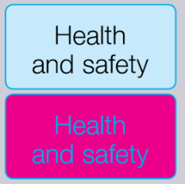  Are characters clear and readable? |  |  | Make sure that the screen is clean and that cleaning materials are available. Check that text and background colours work well together.
Is the screen size suitable for the work you are doing? |  |  | For example, intensive graphic work or work requiring fine attention to small details may require large display screens. Temporary use of a laptop for emails, report writing etc. is fine provided you take regular breaks and break up your routine. Ideally, you need a separate monitor.
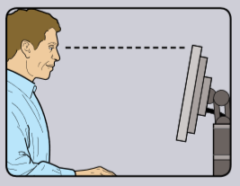  Can you adjust your screen? |  |  | Separate adjustment controls are not essential provided you can read the screen easily at all times. If you are using a laptop, can you tilt the screen or pop it on a book to raise the screen if separate from the keyboard?
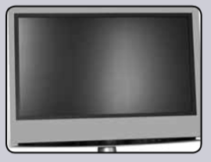  Is the screen free from glare and reflections? |  |  | You might need to physically move the screen, move your location, work at times when the sunlight is not shining directly on your screen or reduce the sunlight using a blind etc. You can also reduce the brightness of the screen, see if that helps.
KEYBOARD
Is the keyboard comfortable to use? |  |  | A laptop can be placed on a book or other object to raise it if necessary.
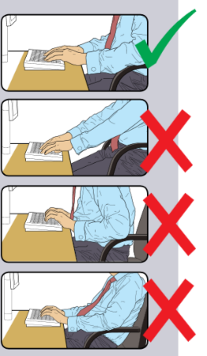  Do you have a comfortable typing position? |  |  | Try pushing the display screen further back to create more room for the keyboard, hands and wrists.
MOUSE/TRACKBALL
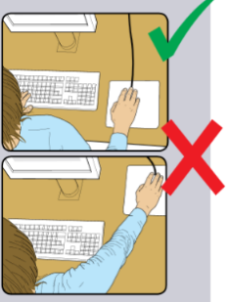  Is the mouse/trackball positioned for easy use? |  |  | Most devices are best placed as close as possible, e.g. right beside the keyboard. The arm should not be overreaching, it should be relaxed and the hand should not be left on the device when it is not being used.
Is there support for your wrist and forearm? |  |  | The user should be able to find a comfortable working position with the device. Support can be gained from the desk surface or the arm of a chair. If not, you can use a cushion to raise you up.
FURNITURE
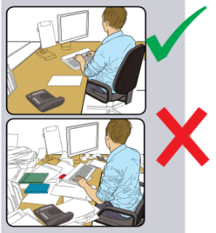  Is your work surface large enough for you to work comfortably? |  |  | It’s important that you can work in a reasonably organised way. If you don’t have a home office, you can work temporarily using a desk, table or even an ironing board (be creative). Try not to use your lap as this can cause aches and pains over a prolonged period.
Is your chair reasonably comfortable? |  |  | It’s not necessary to have an adjustable chair for temporary work, however there are things you can do to improve posture. Placing a cushion or rolled up towel at the base of your spine, placing your feet on a shoe box etc. can help. It is unlikely that your office chair can be provided whilst you are at home so please make the best arrangements you can.
Are your feet flat on the floor? |  |  | If not, a footrest might help (a box or anything to raise your feet) or raise yourself on your chair using a pillow.
ENVIRONMENT
Is the lighting ok so you can work comfortably? |  |  | Try to avoid direct sunlight on your screen. Sometimes it’s good to work outside, provided you can comfortably see the screen without any glare.
OTHER
Do you have any aches, pains or discomfort whilst working at your desk? |  |  | If you are experiencing discomfort, try reorganising your working environment, take regular breaks and walk around for 5-10 mins in every hour just to give yourself a break. Set your alarm, make sure you have an hour lunch break and keep hydrated.
Do you have regular changes in activity? |  |  | Please take frequent short breaks rather than longer more infrequent breaks. Fidgeting and a change of focus is good, coupled with other activities away from the computer work.
Do you have regular contact with colleagues and your line manager? |  |  | It’s important that you do not feel isolated, a regular catch up is a perfect way to discuss any issues or simply to still feel part of a team.

Further information can be found here
HR Guidelines for Staff working from Home
Remote Working Wellbeing
IT Remote Working
IT Advice on which service to use at home

SAFETY SERVICES

April 2020
Covid-19 Briefing
Homeworking with Laptop/Computer

Purpose:
Provide guidance on safety for homeworkers using laptop/computer
Who should read this? | ALL STAFF USING DSE AT HOME
Author: | Andy Lucas MSc CMIOSH MIIRSM, Head of Safety Services

BACKGROUND
With the current ‘lockdown’, staff have been offered the opportunity to continue to work from home. Some staff maybe familiar with homeworking, but others may not be.
This Briefing deals with how the working environment can be set up to make your life easier and working at home more comfortable.
ADVICE
Under normal circumstances, any workstation should be subject to an assessment carried out under the Health and Safety (Display Screen Equipment) Regulations 1992. However, HSE have clarified that temporary DSE work at home presents no greater risk and therefore an assessment is not necessary. However, it is still important to ensure you maintain a good posture, the working environment is safe, you have adequate room at your chosen work station and you take regular breaks.
If you have any specific health issues that may impact on your ability to work from home, please refer any concerns to your line manager in the first instance, it may be that you require specific guidance and support.
Setting Up Your Working Environment
Although a workstation assessment is not necessary, it is still important to remember how to set up your working environment so that it is comfortable. As a guide to help you consider your working arrangements, it is recommended that you run through the HSE Checklist. This is to assist you, rather than to generate a formal assessment.
Generally, please remember:
- Choose your best workspace thinking about lighting, ventilation, space, quiet and comfort
- Always try to rely on natural light – if it feels comfortable, it is likely to be ok
- Set up is really important and you should aim to achieve the following…
PC and Monitor

Laptop
Laptops are slightly different as you may not have a keyboard or separate monitor, however prolonged use of a laptop can increase the risk of long-term neck and shoulder injuries. Prolonged use of a laptop will be subject to the regulations in the same way that desktop equipment is. There is no particular definition of prolonged use, but if it is the only equipment that you have to use at home and it is being used for the majority of the time, then this will be considered ‘prolonged’.
If the laptop is your only option and you are using it for the majority of your work at home, you should use your laptop with a docking station, monitor, keyboard and mouse. Contact your line manager to discuss the possibility of providing this. If this is not possible, use of a laptop should be restricted to short term temporary use and should not be used for prolonged times.
Using Your Laptop
- Set the laptop down on a level solid surface – a desk, table top or similar
- Tilt the screen to avoid reflections and to allow your head to remain level and not leaning forward
- Ideally your forearms should rest on the surface
- Try to sit back to provide good back support in your chair
- The following might be useful

Further guidance when using laptops can be found here:
- https://www.youtube.com/watch?v=xUzi9k9d0EI
- https://www.youtube.com/watch?v=iUHjRFxWygA
If you don’t have ‘all the kit’, be creative…
- A biscuit tin or small box can be a footrest
- Cushions can adjust your height in the chair
- Rolled up towels or a cushion can provide lumbar support
- Books can raise the screen height
- An ironing board can double up as a standing desk
- If you feel you need specialist equipment, please refer to your line manager
- Don’t forget to take regular breaks (5-10mins every hour), change position, get up and walk around, have a stretch, have a chat to someone just to have some connection.
You may find further advice available from HSE
- Setting up your homebased workstation
- Homeworking
- General HSE advice re Covid-19
General Guidance – Getting Through the Next few Months
People working at home can experience difficulties, especially if they are not used to homeworking. It’s common to feel a little isolated, overwhelmed and frustrated. Don’t worry – this is not a normal situation and it is not permanent. There are lots of things that you can do:
- Get up in the morning at your usual time and ‘pretend’ you are going to work.. dress for the part if you like.. (not compulsory)
- Try to keep a routine, start and finish at your usual times
- Start by making a list of things you want to do and try to stick to it
- Take a break away from your work for lunch
- Keep in touch with your line manager and colleagues. If you can, try to video conference using Skype, Zoom, Microsoft Teams etc. and of course social media
- Refer to the HR guidance on working from home
You should expect regular contact with your line manager, and this should be discussed in the early stages of these new working arrangements
You may find the following helpful
- Working at Home
- University of Worcester IT Remote Working
- Microsoft Teams
- HR Working at Home
If you need further help with your arrangements at home, please speak to your line manager in the first instance. If you have any health concerns about working at home please speak to HR as you may require additional Occupational Health Support. If you have general health and safety concerns please refer to Safety Services.
Stay Safe

