PROBATION ONLY
Observation of learning and teaching activity
Updated 20.07.23 with link to Guidance
This form is to be used to record the outcomes of observations of those who deliver and support learning and teaching. Schools should use this form only to provide evidence of satisfactory/unsatisfactory completion of probationary periods for new staff.

The form is based on a standard common framework consisting of five domains which align with Advance HE’s Professional Standards Framework for teaching and supporting learning in higher education 2023 (PSF2023) to support staff gaining external recognition and accreditation for their teaching, learning support, curriculum and professional activities. The Dimensions of the Framework, Professional Values, Core Knowledge, and Areas of Activity are set out in appendix 1 and should be referred to / bracketed in feedback, where they are evident, or where areas of further development are highlighted. It should be used alongside the Guidance [link]. Teaching Observations during a probationary period should be undertaken by a Head of Department, Deputy Head or Head of School.

Section A (to be completed by the observee)
Observee:  (name of staff member being observed) | Teacher Status*:
Module/Course/Programme: | Nature, Type and Purpose of Session  Probation 1 / Probation 2 (delete as appropriate)
Observer/Reviewer: | Date and Time:
Venue: | Number of Students (registered)  Number of Students (in attendance)
Duration of Observation: | Proposed date, time and venue for post observation discussion:
What are the learning outcomes for the session / materials? | How do the learning outcomes for the session relate to the assessment pattern?
How do the learning outcomes relate to module and subject learning outcomes? | Were there any special factors/problems that you took into consideration when planning the session or materials? (Please provide planning ahead of the observation)
Are there any particular aspects which you would like to form the basis for discussion in the pre-meeting or on which you would especially appreciate feedback following the observation?

Pre-observation meeting comments (For probation teaching observations, this should be discussed in a face-to-face meeting).

SECTION B
Brief comments should be recorded under the following headings. These comments should inform the writing of the overall judgement i.e., if more comments in the emerging column, then the judgement overall will be emerging, and the language used will reflect this. Additionally, not all domains will be commented upon in every teaching observation.
Domain | Comments: (These could include reference to PSF 2013 and professional standards e.g., health professionals where appropriate)
- Session content
Shows good command of subject matter as appropriate for HE level for student group

Subject matter is drawn from relevant scholarship, research, professional experience

Shows good command of the subject matter for the teaching and learning strategy of the session

- Management and Organisation
Organises learning activities and subject matter

Evidence of thorough planning and preparation of learning activities and subject matter

Evidence of clear and well thought through learning objectives and structure

Learning is related (where appropriate) to learning resources used in the session and/or pre/post session on the VLE

Demonstrates ability to manage transitions between activities and maintains good order

- Teaching and Learning
Demonstrates enthusiasm for subject and for teaching

Uses a range of questioning techniques

Engages students in active learning

Encourages participation and reflection as appropriate

Provides clear explanations and appropriate intellectual challenge

Uses a range of formative assessments to promote and extend learning

- Awareness and Accessibility

Exhibits positive and inclusive interaction with students together with sensitivity to students’ individual learning styles, personal culture, gender differences and disabilities, responding appropriately to student contributions

Creates an appropriate learning environment

Checks understanding and provides feedback

Ability to reflect upon teaching, learning and assessment strategies

- Student Engagement
Active learning and engagement evident with appropriate interaction and participation by students

Encouragement and support for extending learning both during and outside of the session e.g., use of VLE

Observer overview comments

Areas of good practice to develop and/or share

Areas for future development/targets [SMART]

Further support, action, or outcomes:
On target to pass probation Passed probation
Not on target to pass probation Failed probation
Extend probationary period by 6 months
Professional development needs highlighted following observation:

Observee comments:

Appendix 1 PSF2023
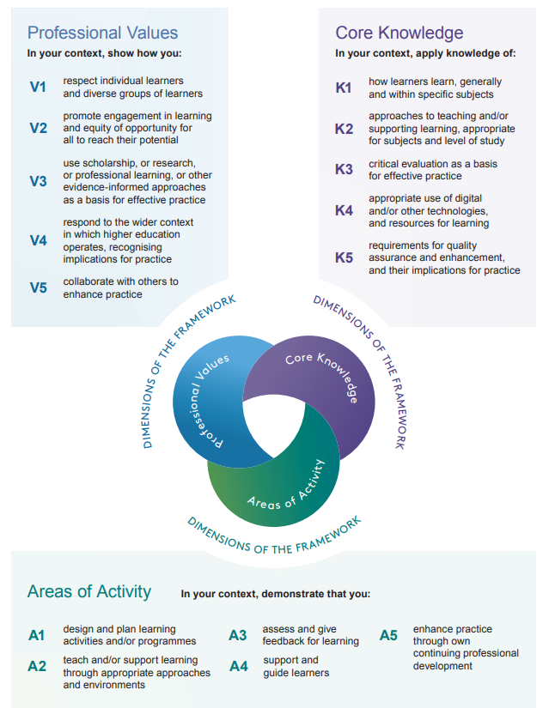
APPENDIX 2: Summary of Performance
Performance summary:
The summary is to be completed at the end of probation. The summary should include a judgement related to not meeting, meeting or exceeding expectations.

Probation Summary
Domain 1: Session Content | UKPSF  Ref | Does not meet expectations | Meets Expectations | Exceeds Expectations
Shows good command of subject matter as appropriate for HE level for student group | A1, A2, A5  K1, K2, K4,  All Values
Subject matter is drawn from relevant scholarship, research, professional experience
Shows good command of the subject matter for the teaching and learning strategy of the session
Domain 2: Management and Organisation |  | Does not meet expectations | Meets Expectations | Exceeds Expectations
Organises learning activities and subject matter | A1, A2, A4  K1, K2, K4  All Values
Evidence of thorough planning and preparation of learning activities and subject matter
Evidence of clear and well thought through learning objectives and structure
Learning is related (where appropriate) to learning resources used in the session and/or pre/post session on the VLE
Demonstrates ability to manage transitions between activities and maintains good order
Domain 3: Teaching and Learning |  | Does not meet expectations | Meets Expectations | Exceeds Expectations
Demonstrates enthusiasm for subject and for teaching | A2, A3, A4  K1-4  All Values
Encourages participation and reflection as appropriate
Provides clear explanations and appropriate intellectual challenge
Domain 4: Awareness and Accessibility |  | Does not meet expectations | Meets Expectations | Exceeds Expectations
Exhibits positive and inclusive interaction with students together with sensitivity to students’ individual learning styles, cultural and educational background, gender differences and disabilities, responding appropriately to student contributions | A2, A4  A4  K1, K2  All Values
Creates an appropriate learning environment
Checks understanding and provides feedback
Ability to reflect upon teaching, learning and assessment strategies
Domain 5: Student Engagement |  | Does not meet expectations | Meets Expectations | Exceeds Expectations
Active learning and engagement evident with appropriate interaction and participation by students | A2, A3, A4  K1-K4  All Values
Encouragement and support for extending learning both during and outside of the session e.g. use of VLE

