How to find your timetable
1. Please log in to your SOLE (or click on SOLE from your MyDay page).
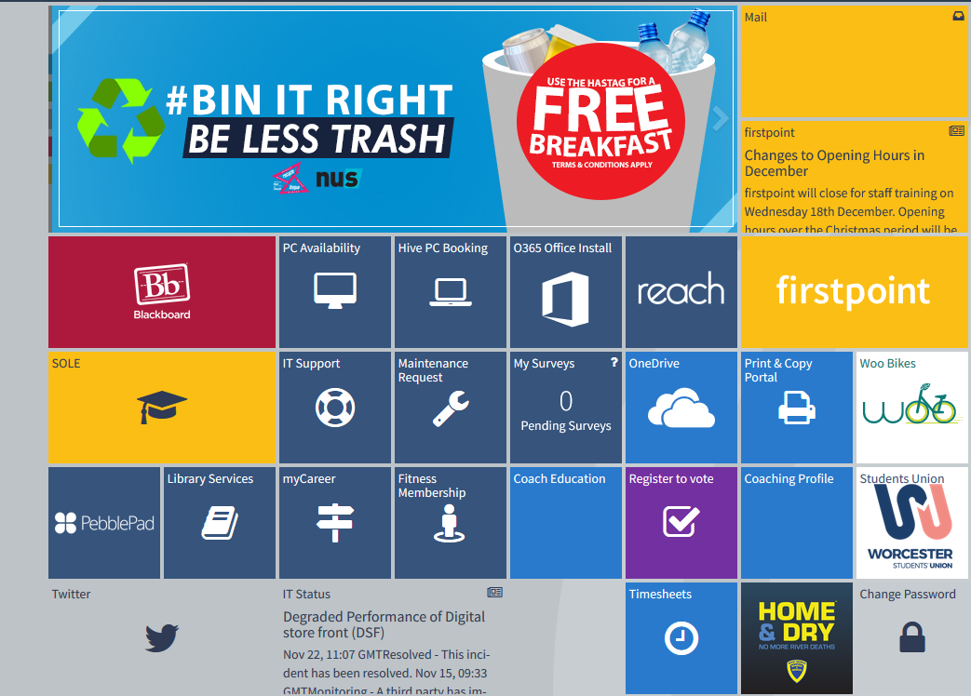
2. On your SOLE homepage, click on the ‘+’ in the top row of tabs to list a drop down of other pages
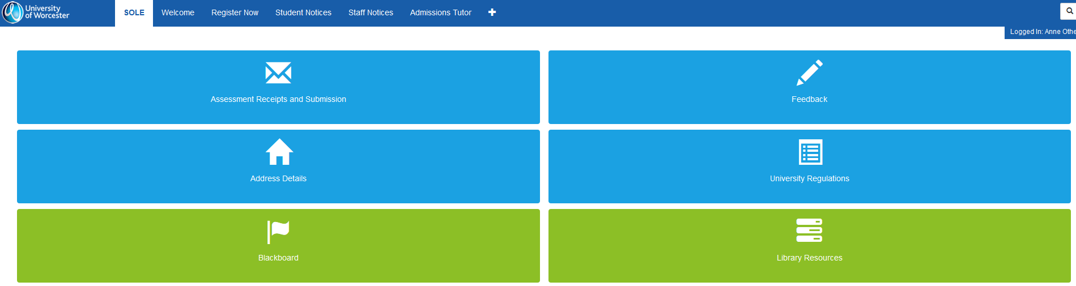
3. Click on ‘Course Information’
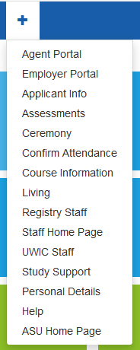

4. Find the ‘Module Information’ section
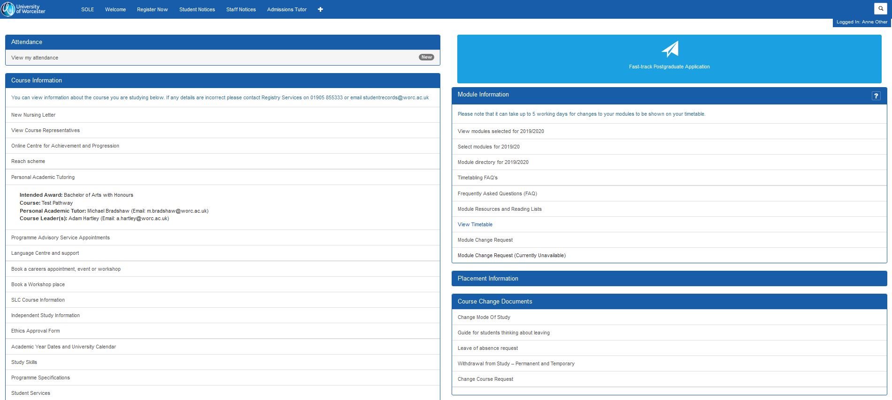
5. Click on ‘View Timetable’
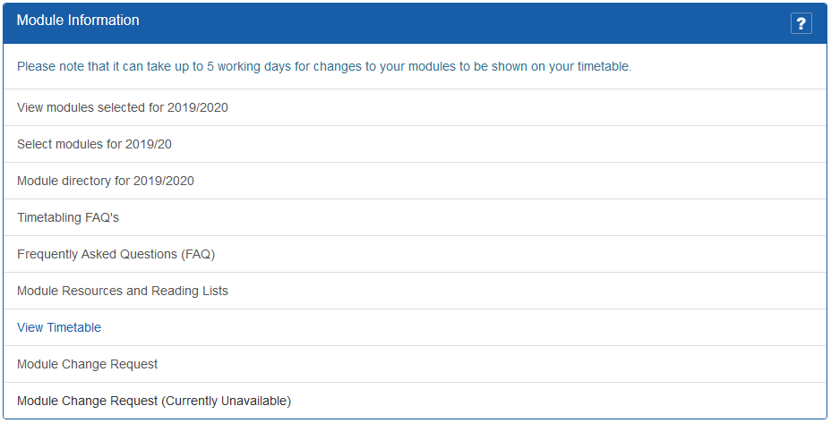
6. This will redirect you to a system called Publish, which is where your timetables are hosted. It may ask you to login, this login will be your University username and password (same for SOLE and MyDay), or it may automatically log you in.
7. Once you have logged in, your timetable may appear blank – please ensure you have tabbed across to the correct week (first week of teaching is usually the last week in September).
Please note – Timetables are subject to change and will be updated on a regular basis. We would advise you to check your online timetable at least once a week to view any changes and to ensure you have the most up to date rooming and scheduling information! There are likely to be continuing room changes throughout the year.
If you have any questions, please contact us at studenttimetabling@worc.ac.uk.

